UNIT – I

Web Application vs Desktop Application
Web Applications | Desktop Applications
Deployment and up-gradation for a web-based application require deployment on a single set of server machines. | Deployment and any up-gradation/patch are done on individual client machines separately.
Web applications can be accessed from anywhere, so there is no location constraint. | As desktop are confined to a standalone machine, so they can be only accessed from the machines they are deployed in.
Web applications are platform-independent, they can work in different types of platforms with the only requirement of a web browser. | Desktop applications need to be developed separately for different platform machines.
Web applications are at higher security risks as they are inherently designed to increase accessibility. | Desktop applications, on the other hand, have better authorization and administrators have better control, hence more secure.
Web applications rely heavily on internet connectivity, for there operation. | Desktop applications don’t require the internet for their operations. Some applications just require internet connectivity at the time of updations.
HTML
- HTML is an acronym which stands for Hyper Text Markup Language which is used for creating web pages and web applications.
- HTML was first created by Tim Berners-Lee, Robert Cailliau, and others starting in 1989.
- HyperText simply means "Text within Text." A text has a link within it, is a hypertext. Whenever you click on a link which brings you to a new webpage, you have clicked on a hypertext. HyperText is a way to link two or more web pages (HTML documents) with each other.
- A markup language is a computer language that is used to apply layout and formatting conventions to a text document. Markup language makes text more interactive and dynamic. It can turn text into images, tables, links, etc.
- A web page is a document which is commonly written in HTML and translated by a web browser. A web page can be identified by entering an URL. A Web page can be of the static or dynamic type. With the help of HTML only, we can create static web pages.

STRUCTURE OF HTML DOCUMENT
The structure of HTML contains
        - <!DOCTYPE>
It defines the document type or it instruct the browser about the version of HTML.
        - <html>
This tag informs the browser that it is an HTML document. Text between html tag describes the web document. It is a container for all other elements of HTML except <!DOCTYPE>
        - <head>
It should be the first element inside the <html> element, which contains the metadata(information about the document). It must be closed before the body tag opens.
        - <title>
As its name suggested, it is used to add title of that HTML page which appears at the top of the browser window. It must be placed inside the head tag and should close immediately. (Optional)
        - <body>
Text between body tag describes the body content of the page that is visible to the end user. This tag contains the main content of the HTML document. The Body tag contains the attributes.
Syn:<HTML>
<HEAD>
<TITLE> Title for Page </TITLE>
</HEAD>
<BODY>
-------------
-------------
</BODY>
</HTML>
HORIZONTAL RULE
- Horizontal lines are produced using the horizontal rule tag, <HR>; To draw a horizontal line all the way across the browser's window.
- The horizontal rule tag has several attributes that are supported by most browsers. They are width, size, noshade and align.
- The width attribute is used to specify how wide the horizontal line should be. The default draws a line that crosses the enter width of the browser window. The width attribute's value can be specified either as a percentage of the browser window's width, or as a fixed number of pixels. Depending on how you are using the horizontal rule tag, one method may be preferable to the other.
- The size attribute allows you to define a taller (thicker) line. Use the NOSHADE attribute, which functions like as witch and has no Value.
<HR [WIDTH] [SIZE][SHADE][NOSHADE]>
Heading Tags
- A HTML heading tag can be defined as a title or a subtitle which you want to display on the webpage. When you place the text within the heading tags<h1>.........</h1>, it is displayed on the browser in the bold format and size of the text depends on the number of heading
- There are six different HTML headings which are defined with the <h1> to <h6> tags, from highest level h1 to the least level h6. H1 is the largest heading tag and H6 is the smallest one. So h1 is used for most important heading and h6 is used for least important.
Syn:<h1 [align]> Heading </h1>
<h2 [align]> Heading </h2>
<h3 [align]> Heading </h3>
<h4 [align]> Heading </h4>
<h5 [align]> Heading </h5>
<h6 [align]> Heading </h6>
Semantic based style types of HTML
A large number of HTML tags are used for specifying different types of text fonts. These tags allow you to enhance the appearance of your web pages, using bold, italics and underlying, highlight an item of importance or to illustrate a definition. There are basically two ways to specify how text should be rendered by a browser.
- Semantic based style type or Content based style types,
- Syntax based style or Physical based style types.

Semantic Based style types:
In which HTML tags are used to indicate the content of the text. A number of most important semantic based style types are
Tag | Description
Emphasis tag | It is used for highlighting text. The emphasis tag <em> with its ending tag </em>Syn: <em> message </em>
Citation tag | It is used to specify a reference. A collection of citation creates a bibliography. Using citation tag facilitates that collection. Since every reference is bracketed between <cite> and </cite>  Syn: <cite> message </cite>
Strong tag | It is used to indicate an even higher level of emphasis. The strong tag <strong> with its ending tag  Syn: <strong> message</strong>
Address tag | It is used to indicate an address. If used throughout a series of web apges, it is easy to automate the process of developing an address book for the pages. The address tag <address> with ending tag </address>Syn:<Address> Message </address>
Kbd tag | It is used to delineate key board input. The keyboard tag <kbd> with ending tag</kbd>  Syn: <kbd> message </kbd>
Variable tag | It is used to indicate an expression as a sequence of letters that has a number of different possible values. The variable tag <var> with ending tag </var>Syn: <var> message </var>
Big tag | It plays the opposite role of an the small tag. The tag <big> with closing tag </big>  Syn: <big> message </big>
Small tag | The text appearing in this tag is made proportionately smaller than the surrounding text. Syn:<small> message</small>
Syntactic Based Style Types
In contrast to semantic based style types, syntactic based style types allow you to tell the browser specifically how you want the text to appear. In the syntactic based style types, the HTML programmer must describe all the formatting details. Here we present the most important syntactic based style types are
Tag | Description
bold tag | It is used to make text in bold face. The bold tag <b> ends with its ending tag </b>  Syn: <b> message </b>
italics tag | It is used to make the text to be italics. The italic tag <i> ends with </i>  Syn: <i> message </i>
Strike tag | It is used for crossing out a word by having a line drawn through it. The strike tag <strike> with its ending tag </strike>
subscript tag | It is used to make a selected text or character to be subscript. The subscript tag <sub> ends with </sub>  Syn:<sub> Message </sub>
superscript tag | It is used to make a selected text or character to be superscript. The superscript tag <sup> ends with </sup>  Syn:<sup> Message </sup>
underline tag | It is used to make a selected text to be underlined. The underline tag <u> ends with </u>
Blink tag | It is used create flashing text. The blink tag <blink> ends with </blink>  Syn: <blink> message </blink>

HTML Quotations
The Quotation elements in HTML are used to insert quoted texts in a web page that is portion of texts different from the normal texts in the web page. Below are some of the most used quotation elements of HTML:
- <q> element:
The <q> element is used to set a set of text inside the quotation marks. It has both opening and closing tags.

Eg::

<html>

<head><title>Quotations</title></head>

<body>

<h3>Future Software Solutions</h3>

<p>The quick brown fox jumps over the lazy dog<br></p>

<p><q>The quick brown fox jumps over the lazy dog</q></p>

</body>

</html>
- <blockquote> element:
The <blockquote> element is also used for quotations in a different way. Instead of putting the text in quotes, it adds space before the start of the sentence, with this tag we can also indent the start of the new paragraph. It has both opening and closing tags.
Eg:<html>

<head><title>Blockquote</title></head>

<body>

<h3>Future Software Solutions</h3>

<p>The quick brown fox jumps over the lazy dog<br></p>

<p><blockquote>The quick brown fox jumps over the lazy dog</blockquote></p>

</body></html>
- <address> element:
Using the <address> element, we can define an address in a webpage and the text put inside the address tag will be emphasized. Usually line break is added before and after the address tag and content inside this tag is generally renders in italic format. It helps screen reader also It has both opening and closing tags.
Eg:

<html>

<head><title>Address</title></head>

<body><h3>Future Software Solutions</h3>

<address>

<p>Address:<br>

710-B, Advant Navis Business Park,<br>

Sector-142, Noida Uttar Pradesh – 201305</p></address>

</body></html>
- <abbr> element:
The <abbr> element is used to define a text as an acronym or abbreviations. The title attribute can be used to show the full version of the abbreviation/acronym when you hover the mouse over the <abbr> element. It has both opening and closing tags. This is useful for browsers and search engines.
Eg:<html>
<head>
<title>Abbreviations</title>
</head>

<body>

<h3>Future Software Solutions</h3>

<p>Welcome to <abbr title="Future Software Solutions">FSS</abbr></p>

</body>

</html>
- <bdo> element:
The <bdo> element is used to define a bidirectional override which means that, the text written from right to left or left to right. It has both opening and closing tags. It is used to over-ride the current text direction. It takes an attribute “rtl” to display the text from right to left.
Eg:

<html><head><title>Bidirectional</title></head>

<body><h3>Future Software Solutions</h3>

<p>The quick brown fox jumps over the lazy dog<br></p>

<p><bdo dir="rtl">The quick brown fox jumps over the lazydog</bdo></p></body></html>
- <cite> element:
This element is used to define a title of a work and emphasizes a text.
Example:

<html><head><title>Cite</title></head>

<body><h3>Future Solutions</h3>

<p>The <cite>GeeksforGeeks</cite> is the best site to<br>

to search for articles and practice problems.</p>

</body></html>

HTML Comments
- Comments are some text or code written in your code to give an explanation about the code, and not visible to the user.
- Comments which are used for HTML file are known as HTML comments. Anything written between these tags will be ignored by the browser, so comments will not be visible on the webpage.
- Comments of any code make code easy to understand and increase readability of code.
- Comments are also part of the code, which gives an explanation of the code.
- You can add comments in your HTML file using <! -- ... --> tag. So if you will write anything between theses comment tag that will be treated as comment and browser will not read it
Eg:<!-- You will not be able to see this text. -->
Image Tag
The IMG tag allows you to display inline images on your web page. The term inline simply means that an image is inserted at a particular location, "inline", with a web page.

The most commonly used image format for inline images is the GIF format. All the current graphic web browser should be able to display GIF images as inline images. Not all current graphical web browsers support the JEP graphics format, which provides file compression and more colors than GIF. The IMG tag is an empty or stand-alone, document element.

<IMG [SRC] [ALT][ALIGN][HEIGHT][WIDTH] [USEMAP]>
<MAP [NAME]>
<AREA [SHAPE] [COORDS] [HREF]>
<AREA [SHAPE] [COORDS] [HREF]>
</MAP>
</IMG>
SRC Attribute:
The SRC attribute used to specify the image filename which we want to insert on web page.
Alt Attribute:
The ALT attribute to provide an alternative to an image in the case of someone using a text-only browser or using a graphical browser with images turned off. The capability of turning off the display of images to help pages load faster
Align Attribute:
The Align attribute allows you to position an inline image relative to the line of text that it is on. All current graphical web browsers recognize these values: "top", "middle" and bottom
Height and width Attributes
The height and width of an inline image can be specified. Normally, a web browser has to download an image before it allocates space for it on a web page. This means that if you have a relatively large graphic, everything else has to wait until the image downloads. If you set the dimensions of the graphic using the HEIGHT and WIDTH attribute of the IMG tag, the browser can allocate space for the graphic, and then display the remainder of the page without waiting for the graphic to download completely.
USEMAP
The USEMAP attribute tells the browser that it's dealing with an imagemap and then directs the browser to where coordinate and URL information for this imagemap can be found. The named anchor will be a MAP element, which consists the same information as a text-based menu, plus a definition of the area on the image map that will active them. The value of USEMAP must be same as the value of NAME in the MAP element.

MAP TAG
MAP elements are contained within the body of the document and have only one attribute, NAME. The Name attribute identifies the particular MAP element referenced with the USEMAP attribute.
AREA TAG:
The AREA element is used within the MAP to delineate a hyperlink and the shape and coordinates of its corresponding hot spot in the image.
<MAP [NAME]>
<AREA [SHAPE] [COORDS] [HREF]>
<AREA [SHAPE] [COORDS] [HREF]>
</MAP>
HTML Tables
It is a container tag. A table represents information in a tabular way, like a spreadsheet distributed across a grid of rows and columns. In web pages using an element called <TABLE> tag and its end with a </TABLE> can create tables. Tables can be used for more than just displaying a table of data. Table can also be used as a formatting tool. The data in a table can be text or images. Web-based table have become an important way to structure document.

A table can contain a variety of row and column definitions within. To define rows in a table an element, <TR> and it ends with a </TR>, Within a table row an element either <TH> or <TD> tag should be used. All these tags should be enclosed with in table tag.
Syn:
<TABLE [BACKGROUND] [BGCOLOR] [BORDER] [BORDERCOLOR]>
<CAPTION [ALIGN] > CAPTION TEXT </CAPTION>
<TR [ALIGN] [VALIGN]>
<TH> DATA </TH>
<TH> DATA </TH>
</TR>
<TR [ALIGN] [VALIGN]>
<Td> DATA </Td>
<Td> DATA </Td>
</TR>
<TR [ALIGN] [VALIGN]>
<Td> DATA </Td>
<Td> DATA </Td>
</TR></TABLE>
Table Attributes
Bgcolor: This attribute is used to change the background color of a page.
Background: This attribute is used to set a background image on a page.
Border - This attribute sets the width of the border around table in pixels. Generally is assumed to this attribute, i.e no border will appear.
Bordercolor - This attribute specifies a color for the table's border.

Table Row Attributes
Align - The Align attribute sets the horizontal spacing for cells on the rows and can be one of the following: left, right or justify.
Valign – The Valign attribute sets the vertical placement of information in the cell and takes one of these values: top, middle or bottom.
Table Data Attributes -
Rowspan&Colspan
These attributes determine its capability to merge with an adjacent cell. The Rowspan and Colspan attributes are used to combine adjacent cells into larger cells. It's important to note that when these attributes are used, the adjacent cells aren't eliminated; they're just "hidden" while the acquiring cell uses their space.
List
Three primary types of list are available in HTML
- Ordered Lists
- Unordered Lists
- Definition lists.
ORDERED LISTS:
In an ordered list, the elements are prefixed by a symbol that denotes their relative order within the list. The most commonly used symbols for marking the elements of an order list are Arabic numbers, letters, and Roman numeral. An order list is used for a series of sequential steps or specifically ordered items. The beginning and ending tags for an ordered list are, <OL> and </OL> respectively.

The beginning tag for each list item is <LI>. No ending tag is necessary for an item. Since the browser can determine the end of a list item by encountering either another list item tag. <LI> or an ending tag for the list, </OL>.

By default the items in an ordered list are numbered using Arabic numbers. The ordered list tag contains an attribute TYPE, it can used take the values as A,B..., a,b,..,I,I,....,i,ii...
Syn: <OL [TYPE]>
<LI> Message
<LI> Message
</OL>
UNORDERED LIST:
The beginning and ending tags for an unordered list are <UL> AND </UL> respectively. A list item tag identifies each item in an unordered list as it was for an ordered list. A bullet prefaces each item, and the default bullet is a shaded disk. It is also possible to use other bullets in HTML. The TYPE attribute is used to make the values as square, circle and disk.
Syn:<UL [TYPE]>
<LI> Message
<LI> Message
</UL>
DEFINITION LISTS:
Definition lists are unordered lists in which each item has two parts - a term, and its corresponding definition. The beginning and ending tags for the definition list are <DL> and </DL> respectively.

Instead of using a list item tag for each item, the term portion requires a definition term tag, <DT>. The definition portion uses a data definition tag <DD> The corresponding ending tags for the definition term and data definition tags are </DT> and </DD> respectively
Syn: <DL>
<DT>Term
<DD> Message
<DT>Term
<DD> Message
</DL>

HTML BLOCKS
        - HTML is the language used to build web pages using different blocks into it. Those elements are styling, divided into two different types
- HTML Blocks level elements and
- inline elements.
        - All these kinds of elements are enclosed into the <body> tag of HTML blocks.
Block-level elements
        - Block-level elements are structured to design the main layout of your web page.
        - If we are talking about the structure view, it creates a bigger structure view than the inline elements view.
        - Every block-level elements start with a new line occupying thefull width of the screen. They must be written within opening <> and closing tag< />.
        - Grouping of elements is an important method to divide layout in the forms of sections or sub-sections. It’s possible to put any block elements into another block element, as well as we are also able to put inline elements into the HTML Blocks elements, but it is not possible to put block-level elements into the inline elements rather than <a> element tag.

Syn:
- div element:
It works as a block element, which takes the full width of the screen and always starts on a new line.
Syn:<div>
{ ……Lines of code…...}
</div>
- table:
table is used to show data in a tabular format including table header, table body having table row and a table column.
Syn:<table>
<tr>
<th></th>
<th></th>
</tr>
<tr>
<td></td>
<td></td>
</tr>
</table>
- Listing elements:
Ordered List & Unordered List.
Eg:
<h6>An Unordered list </h6>
<ul>
<li>item</li>
<li> item </li>
</ul>
<h4>An Ordered list</h4>
<ol>
<li>item</li>
<li> item </li>
</ol>
- Putting form elements:
Putting form elements to create an HTML form as follows.
<form>
<input type=”text” name=” ” />
<textarea rows=” 3” col=”5” name=””></textarea>
<input type=”submit” name=”” />
</form>
Example-1
<html>
<head><title>HTML Block Level Elements </title></head>
<body>
<h1>HTML Block Level Elements </h1>
<p>This is the example of HTML block elements showing multiple block
level elements enclosed within it .Here we can also use inline elements too
</p>
<div>
<h3>Example including div , p , headings elements, list elements</h3>
<p>This example shows different kind of HTML block elements like div, p
, headings in between h1 to h6 </p>
</div>
<h2>Example of Lists</h2>
<h4>An Unordered HTML List showing Countries </h4>
<ul>
<li>Mumbai</li>
<li>Pune</li>
<li>Nagpur</li>
</ul>
<h4>An Ordered HTML List showing Countries</h4>
<ol>
<li>Mumbai</li>
<li>Pune</li>
<li>Nagpur</li>
</ol>
</body>
</html>

HTML Classes

Class Attribute in HTML
- The HTML class attribute is used to specify a single or multiple class names for an HTML element.
- The class name can be used by CSS and JavaScript to do some tasks for HTML elements. You can use this class in CSS with a specific class, write a period (.) character, followed by the name of the class for selecting elements.
- A class attribute can be defined within <style> tag or in separate file using the (.) character.
- In an HTML document, we can use the same class attribute name with different elements.

Defining an HTML class
To create an HTML class, firstly define style for HTML class using <style> tag within <head> section as following example:

Example:<head>

<style>

.headings{

color: lightgreen;

font-family: cursive;

background-color: black;

}

</style>

</head>

We have define style for a class name "headings", and we can use this class name with any of HTML element in which we want to provide such styling. We just need to follow the following syntax to use it.

<tag class="ghf"> content </tag>

Example 1:

<html>

<head>

<style>

.headings{

color: lightgreen;

font-family: cursive;

background-color: black;

}

</style>

</head>

<body>

<h1 class="headings">This is first heading</h1>

<h2 class="headings">This is Second heading</h2>

<h3 class="headings">This is third heading</h3>

<h4 class="headings">This is fourth heading</h4>

</body>

</html>

Example:Use a class name "Fruit" with CSS to style all elements.

<style>

.fruit

{

background-color: orange;

color: white;

padding: 10px;

}

</style>

<h2 class="fruit">Mango</h2>

<p>Mango is king of all fruits.</p>

<h2 class="fruit">Orange</h2>

<p>Oranges are full of Vitamin C.</p>

<h2 class="fruit">Apple</h2>

<p>An apple a day, keeps the Doctor away.</p>

Class Attribute in JavaScript

You can use JavaScript access elements with a specified class name by using the getElementsByClassName() method.

Multiple Classes

You can use multiple class names (more than one) with HTML elements. These class names must be separated by a space.

Eg: <html>

<style>

.fruit{ background-color: orange;

color: white;

padding: 10px;

}

.center { text-align: center; }

</style>

<body>

<h2>Multiple Classes</h2>

<p>All three elements have the class name "fruit". In addition, Mango also have the class name "center", which center-aligns the text.</p>

<h2 class="fruit center">Mango</h2>

<h2 class="fruit">Orange</h2>

<h2 class="fruit">Apple</h2>

</body>

</html>

Same class with Different Tag

You can use the same class name with different tags like <h2> and <p> etc. to share the same style.

Example:

<html>

<style>

.fruit {

background-color: orange;

color: white;

padding: 10px; }

</style>

<body>

<h2>Same Class with Different Tag</h2>

<h2 class="fruit">Mango</h2>

<p class="fruit">Mango is the king of all fruits.</p>

</body></html>
Frames and Frameset
A framed document divides a browser window into multiple panes or smaller window frames. Each frame may contain a different document. Users can view information in on frame while keeping another frame open for reference, instead of moving back and forth between pages. The contents of one frame can be manipulated, or linked to the contents of another. This allows designers to build sophisticated interfaces.

A frame is an independent scrolling region, or window, of a web page. Every web page may be divided up into many individual frames, which can even be nested within other frames. Fixed screen sizes limit how many frames can realistically be used at once. Frames provide navigation facilities.
FRAMESET:
The FRAMESET element allows the user divide a window to more than one section. To specify a framing document, the <FRAMESET> element is used in the HTML file instead of the <BODY> element. This element defines the set of frames that make up the document.
Syn:<FRAMESET [BORDER] [BORDERCOLOR] [COLS/ROWS] [TITLE]>
<FRAME [NAME] [SRC][NORESIZE] [SCROLLING]>
<FRAME [NAME] [SRC][NORESIZE] [SCROLLING]>
</FRAMESET>
File Paths
- An HTML file path is used to describe the location of a file in a website folder.
- File paths are like an address of file for a web browser.
- We can link any external resource to add in our HTML file with the help of file paths such as images, file, CSS file, JS file, video, etc.
- The src or href attribute requires an attribute to link any external source to HTML file.
- Following are the different types to specify file paths:
- <img src="picture.jpg"> It specifies that picture.jpg is located in the same folder as the current page.
- <img src="images/picture.jpg"> It specifies that picture.jpg is located in the images folder in the current folder.
- <img src="/images/picture.jpg"> It specifies that picture.jpg is located in the images folder at the root of the current web.
- <img src="../picture.jpg"> It specifies that picture.jpg is located in the folder one level up from the current folder.
- File paths are used on webpages to link external files like:
- Web pages
- Images
- Style sheets
- JavaScript
Types of File Paths
There are two types of File Paths:
- Absolute File Paths
- Relative File Paths
Absolute File Paths
Absolute file path specifies full URL address.
Eg:
<html>
<body>
<h2>Using a Full URL File Path</h2>
<img src="https://www.futuresoft.com/images/nature-1.jpg" alt="image" style="width:300px">
</body>
</html>
Relative File Paths
The relative file path specifies to a file which is related to the location of current page.
Eg:
<html>
<body>
<h2>Using a Relative File Path</h2>
<img src="/images/nature-2.jpg" alt="Mountain" style="width:300px">
</body></html>

HTML Layouts

HTML layouts provide a way to arrange web pages in well-mannered, well-structured, and in responsive form or we can say that HTML layout specifies a way in which the web pages can be arranged. Web-page layout works with arrangement of visual elements of an HTML document.
Web page layout is the most important part to keep in mind while creating a website so that our website can appear professional with the great look. You can also use CSS and JAVASCRIPT based frameworks for creating layouts for responsive and dynamic website designing.
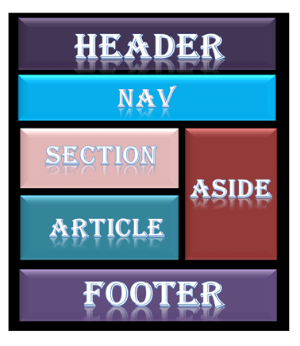
Every website has a specific layout to display content in a specific manner.
Following are different HTML5 elements which are used to define the different parts of a webpage.
- <header>: It is used to define a header for a document or a section.
- <nav>: It is used to define a container for navigation links
- <section>: It is used to define a section in a document
- <article>: It is used to define an independent self-contained article
- <aside>: It is used to define content aside from the content (like a sidebar)
- <footer>: It is used to define a footer for a document or a section
- <details>: It is used to define additional details
- <summary>: It is used to define a heading for the <details> element

Various Layout elements
- HTML <header>
The <header> element is used to create header section of web pages. The header contains the introductory content, heading element, logo or icon for the webpage, and authorship information.

Eg:
<header style="background-color: #303030; height: 80px; width: 100%">
<h1 style="font-size: 30px; color: white;text-align: center; padding-top: 15px;">Welcome to MyFirstWebpage</h1> </header>
- HTML <nav>
The <nav> elements is a container for the main block of navigation links. It can contain links for the same page or for other pages.

Eg: <nav style="background-color:#bcdeef;">
<h1 style="text-align: center;">Navgation Links</h1>
<ul>
<li><a href="#">link1</a></li>
<li><a href="#">link2</a></li>
<li><a href="#">link3</a></li>
<li><a href="#">link4</a></li>
</ul> </nav>
- HTML <section>
HTML <section> elements represent a separate section of a web page which contains related element grouped together. It can contain: text, images, tables, videos, etc.

Eg:
<section style="background-color:#ff7f50; width: 100%; border: 1px solid black;">
<h2>Introduction to HTML</h2>
<p>HTML is a markup language which is used for creating attractive web pages with the help of styling, and which looks in a nice format on a web browser.</p></section>
- HTML <article>
The HTMLtag is used to contain a self-contained article such as big story, huge article, etc.

Eg:
<article style="width: 100%; border:2px solid black; background-color: #fff0f5;">
<h2>History of Computer</h2>
<p>Write your content here for the history of computer</p>
</article>

- HTML <aside>
HTML <aside> define aside content related to primary content. The <aside> content must be related to the primary content. It can function as side bar for the main content of web page.

Eg: <aside style="background-color:#e6e6fa">
<h2>Sidebar information</h2>
<p>This conatins information which will represent like a side bar for a webpage</p>
</aside>
- HTML <footer>
HTML <footer> element defines the footer for that document or web page. It mostly contains information about author, copyright, other links, etc.

Eg:<footer style="background-color: #f0f8ff; width: 100%; text-align: center;">
<h3>Footer Example</h3>
<p>© Copyright 2018-2020. </p> </footer>
- HTML <details>
HTML <details> element is used to add extra details about the web page and use can hide or show the details as per requirement.

Eg:
<details style="background-color: #f5deb3">
<summary>This is visible section: click to show other details</summary>
<p>This section only shows if user want to see it. </p>
</details>
- HTML <summary>
HTML <summary> element is used with the <details> element in a web page. It is used as summary, captions about the content of <details> element.

Eg:
<details>
<summary>HTML is acronym for?</summary>
<p style="color: blue; font-size: 20px;">Hypertext Markup Language</p>
</details>

HTML Responsive
Responsive Web design
- Responsive web design is used to make your web page look appropriate, good, and well placedon all devices (desktop, tablet, smartphone etc.)
- Responsive web design uses HTML and CSS to resize, hide, shrink, enlarge, or move the content. It makes the content look good on any screen.
Set the viewport
To create a responsive website, add the following <meta> tag to all your web pages:

<meta name="viewport" content="width=device-width, initial-scale=1.0">

Responsive Images
Images which can be scaled nicely to fit any browser size are known as responsive images.

How to make Image Responsive?
- By using the width property
Set the CSS width property to 100% to make the image responsive and scale up and down.
Example
<html> <body> <h2>Responsive Image</h2>
<p>When we set the CSS width property to 100%, it makes the image responsive.Resize the browser window to see the effect.</p>
<img src="img_girl.jpg" style="width:100%;">( change image)
</body> </html>
- By using the max-width Property
This method is best and most used because it facilitates that the image will scale down if it has to, but never scale up to be larger than its original size.
Eg
<html>
<body><h2>Responsive Image</h2>
<p>"max-width:100%"makes the image responsive and also ensures
that the image doesn't get bigger than its original size.</p>
<p>Resize the browser window to see the effect.</p>
<img src="img_girl.jpg" style="maxwidth:100%;height:auto;"> (Change the image)
</body> </html>
Responsive Text-size
We can make the text size responsive by using the "uv" unit. It means viewport-width. By using this, we can make the text size to follow the browserwindow screen.
Example
<html>
<meta name="viewport" content="width=device-width, initial-scale=1.0">
<body>
<h1 style="font-size:10vw;">Here size is 10vw.</h1>
<p style="font-size:6vw;">Here size is 6vw.</p>
<p style="font-size:4vw;">Here size is 4vw.</p>
<p>Resize the browser window to see how the text size changes.</p>
</body>
</html>
SYMBOLS IN HTML
Many mathematical, technical, and currency symbols, are not present on a normal keyboard. To add such symbols to an HTML page, you can use the entity name or the entity number (a decimal or a hexadecimal reference) for the symbol.
Eg: Display the euro sign, €, with an entity name, a decimal, and a hexadecimal value:
<p>I will display &euro;</p>
<p>I will display &#8364;</p>
<p>I will display &#x20AC;</p>
o/p:
I will display €
I will display €
I will display €
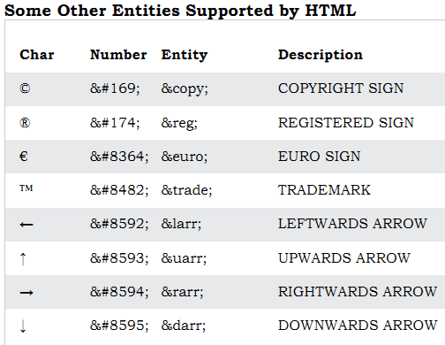
UNIT – II
Input Types
In HTML <input type=" "> is an important element of HTML form. The "type" attribute of input element can be various types, which defines information field. Such as <input type="text" name="name"> gives a text box.

Following is a list of all types of <input> element of HTML.
type=" " | Description
Text | Defines a one-line text input field
password | Defines a one-line password input field
submit | Defines a submit button to submit the form to server
Reset | Defines a reset button to reset all values in the form.
Radio | Defines a radio button which allows select one option.
checkbox | Defines checkboxes which allow select multiple options form.
button | Defines a simple push button, which can be programmed to perform a task on an event.
File | Defines to select the file from device storage.
image | Defines a graphical submit button.
HTML5 added new types on <input> element. Following is the list of types of elements of HTML5
type=" " | Description
Color | Defines an input field with a specific color.
Date | Defines an input field for selection of date.
datetime-local | Defines an input field for entering a date without time zone.
Email | Defines an input field for entering an email address.
Month | Defines a control with month and year, without time zone.
Number | Defines an input field to enter a number.
url | Defines a field for entering URL
Week | Defines a field to enter the date with week-year, without time zone.
Search | Defines a single line text field for entering a search string.
Tel | Defines an input field for entering the telephone number.
Following is the description about types of <input> element with examples.

<input type="text">:
<input> element of type "text" are used to define a single-line input text field.

Example:
<form>
<label>Enter first name</label><br>
<input type="text" name="firstname"><br>
<label>Enter last name</label><br>
<input type="text" name="lastname"><br>
<p><strong>Note:</strong>The default maximum cahracter lenght is 20.</p>
</form>

<input type="password">:

The <input> element of type "password" allow a user to enter the password securely in a webpage. The entered text in password filed converted into "*" or ".", so that it cannot be read by another user.

Example:
<form>
<label>Enter User name</label><br>
<input type="text" name="firstname"><br>
<label>Enter Password</label><br>
<input type="Password" name="password"><br>
<br><input type="submit" value="submit">
</form>

<input type="submit">:

The <input> element of type "submit" defines a submit button to submit the form to the server when the "click" event occurs.

Example:
<form action="https://www.javatpoint.com/html-tutorial">
<label>Enter User name</label><br>
<input type="text" name="firstname"><br>
<label>Enter Password</label><br>
<input type="Password" name="password"><br>
<br><input type="submit" value="submit">
</form>

<input type="reset">:
The <input> type "reset" is also defined as a button but when the user performs a click event, it by default reset the all inputted values.

Example:
<form>
<label>User id: </label>
<input type="text" name="user-id" value="user">
<label>Password: </label>
<input type="password" name="pass" value="pass"><br><br>
<input type="submit" value="login">
<input type="reset" value="Reset">
</form>

<input type="radio">:
The <input> type "radio" defines the radio buttons, which allow choosing an option between a set of related options. At a time only one radio button option can be selected at a time.

Example:
<form>
<p>Kindly Select your favorite color</p>
<input type="radio" name="color" value="red"> Red <br>
<input type="radio" name="color" value="blue"> blue <br>
<input type="radio" name="color" value="green">green <br>
<input type="radio" name="color" value="pink">pink <br>
<input type="submit" value="submit">
</form>

<input type="checkbox">:
The <input> type "checkbox" are displayed as square boxes which can be checked or unchecked to select the choices from the given options.

Example:
<form>
<label>Enter your Name:</label>
<input type="text" name="name">
<p>Kindly Select your favourite sports</p>
<input type="checkbox" name="sport1" value="cricket">Cricket<br>
<input type="checkbox" name="sport2" value="tennis">Tennis<br>
<input type="checkbox" name="sport3" value="football">Football<br>
<input type="checkbox" name="sport4" value="baseball">Baseball<br>
<input type="checkbox" name="sport5" value="badminton">Badminton<br>
<input type="submit" value="submit">
</form>

<input type="button">:
The <input> type "button" defines a simple push button, which can be programmed to control a functionally on any event such as, click event.

Example:
<form>
<input type="button" value="Clcik me " onclick="alert('you are learning HTML')">
</form>

<input type="file">:
The <input> element with type "file" is used to select one or more files from user device storage. Once you select the file, and after submission, this file can be uploaded to the server with the help of JS code and file API.

Example:
<form>
<label>Select file to upload:</label>
<input type="file" name="newfile">
<input type="submit" value="submit">
</form>

<input type="image">:
The <input> type "image" is used to represent a submit button in the form of image.

Example:
<html>
<body> <h2>Input "image" type.</h2>
<p>We can create an image as submit button</p>
<form> <label>User id:</label><br>
<input type="text" name="name"><br><br>
<input type="image" alt="Submit" src="login.png" width="100px">
</form> </body> </html>

HTML5 newly added <input> types element

<input type="color">:
The <input> type "color" is used to define an input field which contains a colour. It allows a user to specify the colour by the visual colour interface on a browser.

Example:
<form>
Pick your Favorite color: <br><br>
<input type="color" name="upclick" value="#a52a2a"> Upclick<br><br>
<input type="color" name="downclick" value="#f5f5dc"> Downclick
</form>

<input type="date">:
The <input> element of type "date" generates an input field, which allows a user to input the date in a given format. A user can enter the date by text field or by date picker interface.

Example:
<form> Select Start and End Date: <br><br>
<input type="date" name="Startdate"> Start date:<br><br>
<input type="date" name="Enddate"> End date:<br><br>
<input type="submit">
</form>

<input type="datetime-local">:

The <input> element of type "datetime-local" creates input filed which allow a user to select the date as well as local time in the hour and minute without time zone information.

Example:
<form> <label> Select the meeting schedule: <br><br>
Select date & time: <input type="datetime-local" name="meetingdate"> <br><br> </label>
<input type="submit"> </form>

<input type="email">:
The <input> type "email" creates an input filed which allow a user to enter the e-mail address with pattern validation. The multiple attributes allow a user to enter more than one email address.

Example:
<form>
<label><b>Enter your Email-address</b></label>
<input type="email" name="email" required>
<input type="submit"> <p><strong>Note:</strong>User can also enter multiple email addresses separating by comma or whitespace as following:</p>
<label><b>Enter multiple Email-addresses</b></label>
<input type="email" name="email" multiple>
<input type="submit">
</form>

<input type="month">:
The <input> type "month" creates an input field which allows a user to easily enter month and year in the format of "MM, YYYY" where MM defines month value, and YYYY defines the year value. New

Example:
<form> <label>Enter your Birth Month-year: </label>
<input type="month" name="newMonth">
<input type="submit"> </form>

<input type="number">:
The <input> element type number creates input filed which allows a user to enter the numeric value. You can also restrict to enter a minimum and maximum value using min and max attribute.

Example:
<form> <label>Enter your age: </label>
<input type="number" name="num" min="50" max="80">
<input type="submit">
</form>

<input type="url">:
The <input> element of type "url" creates an input filed which enables user to enter the URL.

Example:
<form> <label>Enter your website URL: </label>
<input type="url" name="website" placeholder="http://example.com"><br>
<input type="submit" value="send data">
</form>

<input type="week">:
The <input> type week creates an input field which allows a user to select a week and year form the drop-down calendar without time zone.

Example:
<form>
<label><b>Select your best week of year:</b></label><br><br>
<input type="week" name="bestweek">
<input type="submit" value="Send data">
</form>

<input type="search">:
The <input> type "search" creates an input filed which allows a user to enter a search string. These are functionally symmetrical to the text input type, but may be styled differently.

Eg:<form>
<label>Search here:</label>
<input type="search" name="q">
<input type="submit" value="search">
</form>

<input type="tel">:

The <input> element of type ?tel? creates an input filed to enter the telephone number. The "tel" type does not have default validation such as email, because telephone number pattern can vary worldwide.

Example:
<form>
<label><b>Enter your Telephone Number(in format of xxx-xxx-xxxx):</b></label>
<input type="tel" name="telephone" pattern="[0-9]{3}-[0-9]{3}-[0-9]{4}" required>
<input type="submit">
<br>
<br>
</form>

HTML Form
Forms are constructed in the HTML documents by using the <FORM> element. This element contains several other elements, called controls that have a variety of methods for gathering information. When a form is completed and submitted, the information in its active controls is passed to a program that takes whatever action the form has been designed to perform. Each element in the form has both a name and a value, thus the data that's passed for processing in the form of name/value pairs.

Scripting languages or CGI program does the processing of data. CGI programs are written in the languages - Perl, Java and C. The FORM element has three main attributes. They are
- Name - This attribute gives a name to the form.
- Action
This attribute gets an URL that specifies the address of the program used for processing the data.
- Method
This attribute can have either GET or POST as its value; GET is the default value choice. It submits the name/value pairs to the URL specified in the METHOD attribute as an appendage to the URL itself; POST on the other hand, sends them as a separate section following the HTTP header. This separate section is called the entity body. But the last two attributes are required only when dealing with Active Server Pages.
Syn:
<FORM [NAME] [ACTION] [METHOD]>
Form Elements
Form Elements
</FORM>
Multimedia objects
Sometimes you need to add music or video into your web page. The easiest way to add video or sound to your web site is to include the special HTML tag called <embed>. This tag causes the browser itself to include controls for the multimedia automatically provided browser supports <embed> tag and given media type.

You can also include a <noembed> tag for the browsers which don't recognize the <embed> tag. You could, for example, use <embed> to display a movie of your choice, and <noembed> to display a single JPG image if browser does not support <embed> tag.
Example to play an embedded midi file
<html>
<head>
<title>HTML embed Tag</title>
</head>
<body>
<embed src = "/html/yourfile.mid" width = "100%" height = "60" >
<noembed>
<imgsrc = "yourimage.gif" alt = "Alternative Media" >
</noembed>
</embed>
</body>
</html>

The <embed> Tag Attributes
Following is the list of important attributes which can be used with <embed> tag.
Attribute | Description
Align | Determines how to align the object. It can be set to either center, left or right.
Autostart | This boolean attribute indicates if the media should start automatically. You can set it either true or false.
Loop | Specifies if the sound should be played continuously (set loop to true), a certain number of times (a positive value) or not at all (false)
Playcount | Specifies the number of times to play the sound. This is alternate option for loop if you are using IE.
Hidden | Specifies if the multimedia object should be shown on the page. A false value means no and true values means yes.
Width | Width of the object in pixels
Height | Height of the object in pixels
Name | A name used to reference the object.
Src | URL of the object to be embedded.
Volume | Controls volume of the sound. Can be from 0 (off) to 100 (full volume).

Supported Video Types
You can use various media types like Flash movies (.swf), AVI's (.avi), and MOV's (.mov) file types inside embed tag.
- .swf files − are the file types created by Macromedia's Flash program.
- .wmv files − are Microsoft's Window's Media Video file types.
- .mov files − are Apple's Quick Time Movie format.
- .mpeg files − are movie files created by the Moving Pictures Expert Group.

<!-- Example to play an embedded video file-->
<body>
<embed src = "/html/yourfile.swf" width = "200" height = "200" >
<noembed>
<img src = "yourimage.gif" alt = "Alternative Media" ></noembed>
</embed>
</body>

Background Audio
You can use HTML <bgsound> tag to play a soundtrack in the background of your webpage. This tag is supported by Internet Explorer only and most of the other browsers ignore this tag. It downloads and plays an audio file when the host document is first downloaded by the user and displayed. The background sound file also will replay whenever the user refreshes the browser. This tag is having only two attributes loop and src.
Example to play a small midi file
<body>
<bgsoundsrc = "/html/yourfile.mid">
<noembed><imgsrc = "yourimage.gif" ></noembed>
</bgsound>
</body>
This will produce the blank screen. This tag does not display any component and remains hidden. Internet Explorer can also handle only three different sound format files − wav, the native format for PCs; au, the native format for most Unix workstations; and MIDI, a universal music-encoding scheme.

HTML Object tag
HTML 4 introduces the <object> element, which offers an all-purpose solution to generic object inclusion. The <object> element allows HTML authors to specify everything required by an object for its presentation by a user agent.

Example - 1
You can embed an HTML document in an HTML document itself as follows
<object data = "data/test.htm" type = "text/html" width = "300" height ="200">
alt :<a href = "data/test.htm">test.htm</a></object>

Example - 2
You can embed a PDF document in an HTML document as follows −
<object data = "data/test.pdf" type = "application/pdf" width = "300" height = "200">
alt :<a href = "data/test.pdf">test.htm</a></object>

Example - 3
<object data = "data/test.wav" type = "audio/x-wav" width = "200" height = "20">
<param name = "src" value = "data/test.wav">
<param name = "autoplay" value = "false">
<param name = "autoStart" value = "0">
alt :<a href = "data/test.wav">test.wav</a>
</object>
Example - 4
You can add a flash document as follows −
<object classid = "clsid:D27CDB6E-AE6D-11cf-96B8-444553540000" id = "penguin" codebase = "someplace/swflash.cab" width = "200" height = "300">
<param name = "movie" value = "flash/penguin.swf" />
<param name = "quality" value = "high" />
<imgsrc = "penguin.jpg" width = "200" height = "300" alt = "Penguin" />
</object>
YOUTUBE IN HTML
The easiest way to play videos in HTML, is to use YouTube.
Struggling with Video Formats:
- Converting videos to different formats can be difficult and time-consuming.
- An easier solution is to let YouTube play the videos in your web page.
YouTube Video Id
- YouTube will display an id (like tgbNymZ7vqY), when you save (or play) a video.
- You can use this id, and refer to your video in the HTML code.
Playing a YouTube Video in HTML
To play your video on a web page, do the following:
  - Upload the video to YouTube
  - Take a note of the video id
  - Define an <iframe> element in your web page
  - Let the src attribute point to the video URL
  - Use the width and height attributes to specify the dimension of the player
  - Add any other parameters to the URL

Eg:<iframe width="420" height="315"
src="https://www.youtube.com/embed/tgbNymZ7vqY">
</iframe>
YouTube Autoplay + Mute
You can let your video start playing automatically when a user visits the page, by adding autoplay=1 to the YouTube URL. However, automatically starting a video is annoying for your visitors!

Add mute=1 after autoplay=1 to let your video start playing automatically (but muted).
YouTube - Autoplay + Muted
<iframe width="420" height="315"
src="https://www.youtube.com/embed/tgbNymZ7vqY?autoplay=1&mute=1">
</iframe>
YouTube Playlist
A comma separated list of videos to play (in addition to the original URL).

YouTube Loop
Add loop=1 to let your video loop forever.
Value 0 (default): The video will play only once.
Value 1: The video will loop (forever).

YouTube - Loop
<iframe width="420" height="315"
src="https://www.youtube.com/embed/tgNymZ7vqY?playlist=tgbNymZ7vqY&loop=1">
</iframe>

HTML5
- HTML5 is the next major revision of the HTML standard superseding HTML 4.01, XHTML 1.0, and XHTML 1.1.
- HTML5 is a standard for structuring and presenting content on the World Wide Web.
- HTML5 is a co-operation between the World Wide Web Consortium (W3C) and the Web Hypertext Application Technology Working Group (WHATWG).
- The new standard incorporates features like video playback and drag-and-drop that have been previously dependent on third-party browser plug-ins such as Adobe Flash, Microsoft Silverlight, and Google Gears.
- The latest versions of Apple Safari, Google Chrome, Mozilla Firefox, and Opera all support many HTML5 features and Internet Explorer 9.0 will also have support for some HTML5 functionality.
- The mobile web browsers that come pre-installed on iPhones, iPads, and Android phones all have excellent support for HTML5.
- HTML5 introduces a number of new elements and attributes that can help you in building modern websites. Here is a set of some of the most prominent features introduced in HTML5.
- New Semantic Elements − These are like <header>, <footer>, and <section>.
- Forms 2.0 − Improvements to HTML web forms where new attributes have been introduced for <input> tag.
- Persistent Local Storage − To achieve without resorting to third-party plugins.
- WebSocket − A next-generation bidirectional communication technology for web applications.
- Server-Sent Events − HTML5 introduces events which flow from web server to the web browsers and they are called Server-Sent Events (SSE).
- Canvas − This supports a two-dimensional drawing surface that you can program with JavaScript.
- Audio & Video − You can embed audio or video on your webpages without resorting to third-party plugins.
- Geolocation − Now visitors can choose to share their physical location with your web application.
- Microdata − This lets you create your own vocabularies beyond HTML5 and extend your web pages with custom semantics.
- Drag and drop − Drag and drop the items from one location to another location on the same webpage.
HTML GRAPHICS
- Graphics are representations used to make web-page or applications visually appealing and also for improving user experience and user interaction.
- Some examples of graphics are photographs, flowcharts, bar graphs, maps, engineering drawings, constructional blueprints, etc.
- Usually, the following technologies are used in web graphics with HTML5 Canvas API, WebCGM, CSS, SVG, PNG, JPG, etc.
SVG (Scalable Vector Graphics)
- These are images created by a markup language that are reusable, simple, high-quality standalone images that can be exported and imported as well.
- They are cross-browser friendly and can be used both on the client-side and server-side of the application.
- They can be manipulated to create animations, hybrid images, etc by editing the markup language or by editing using a stylesheet.
- Files come with a .svg extension.
Eg:
<body>
<svg width="550" height="50" viewBox="0 0 550 50"fill="green" xmlns="http://www.w3.org/2000/svg">
<text x="0" y="20">I love GeeksforGeeks</text>
</body>
</html>
PNG (Portable Network Graphics)
- They are portable, static and lossless with proper indexed-color control.
- Files come with a .png or .PNG extension.
- Cross-browser friendly and have streaming capabilities.
Eg:
<html lang="en">
<head></head>
<body>
<img src="https://media.future.org/wp-content/uploads/20210729182205/Component1-300x258.png">
</img>
</body>
</html>

JPG or JPEG (Joint Photographic Experts Group)
- Lossy compressed with an adjustable degree of compression.
- Used mainly with digital photography and can achieve a compression of 10:1.
- Files come with a .jpg or jpeg extension.
Eg:
<html lang="en">
<head></head>
<body>
<img src="https://media.future.org/wp-content/uploads/20210729183033/Component2-300x189.jpg"></img>
</body>
</html>
8Q)GeoLocation
- The Geolocation is one of the best HTML5 API which is used to identify the user's geographic location for the web application.
- This new feature of HTML5 allows you to navigate the latitude and longitude coordinates of the current website's visitor. These coordinates can be captured by JavaScript and send to the server which can show your current location on the website
- Most of the geolocation services use Network routing addresses such as IP addresses, RFID, WIFI and MAC addresses or internal GPS devices to identify the user's location.

Geolocation object
- The Geolocation API is work with the navigation.geolocation object.
- Its read-only property returns a Geolocation object which identifies the location of the user and can generate a customized result based on user location.

Syn:geo=navigator. geolocation;
- If this object is present, then you can get the geolocation services.

Methods
The Geolocation API uses three methods of Geolocation interface which are given following:
Methods | Description
getCurrentPosition() | It identifies the device or the user's current location and returns a position object with data.
watchPosition() | Return a value whenever the device location changes.
clearWatch() | It cancels the previous watchPosition() call

Checking for browser support:
The geolocation property of navigator.geolcation object helps to determine the browser support for the Geolocation API.
<html>
<head>
<title>Geolocation API</title>
</head>
<body>
<h1>Find your Current location</h1>
<button onclick="getlocation()">Click me</button>
<div id="location"></div>
<script>
var x= document.getElementById("location");
function getlocation() {
if(navigator.geolocation){
alert("your browser is supporting Geolocation API")
}
else
{
alert("Sorry! your browser is not supporting")
}
}
</script> </body></html>

Getting the User's current position:
To get the user's current location, getCurrentPosition() method of the navigator.geolocation object is used. This method accepts three parameters:
- success: A success callback function to get the location of the user
- error: An error callback function which takes "Position Error" object as input.
- options: It defines various options for getting the location.
Example will return the longitude and latitude of the visitor's current location.
<html>
<head> <title>Geolocation API</title> </head>
<body> <h1>Find your Current location</h1>
<button onclick="getlocation()">Click me</button>
<div id="location"></div>
<script>
var x= document.getElementById("location");
function getlocation() {
if(navigator.geolocation)
navigator.geolocation.getCurrentPosition(showPosition)
else
alert("Sorry! your browser is not supporting")
}
function showPosition(position){
var x = "Your current location is (" + "Latitude: " + position.coords.latitude + ", " + "Longitude: " + position.coords.longitude + ")";
document.getElementById("location").innerHTML = x;
}
</script>
</body></html>

Displaying location on Google Map
Till now, we have seen how to show your location using latitude and longitude values, but it is not sufficient. Hence we can also show the exact location on Google map with this API.
Eg:
<html>
<head> <title>Geolocation API</title> </head>
<body> <h2>Find Your Location in below Map</h2>
<button onclick="getlocation();"> Show Position</button>
<div id="demo" style="width: 600px; height: 400px; margin-left: 200px;"></div>
<script src="https://maps.google.com/maps/api/js?sensor=false"> </script>
<script type="text/javascript">
function getlocation(){
if(navigator.geolocation){
navigator.geolocation.getCurrentPosition(showPos, showErr);
}
else{
alert("Sorry! your Browser does not support Geolocation API")
}
}
function showPos(position){
latt = position.coords.latitude;
long = position.coords.longitude;
var lattlong = new google.maps.LatLng(latt, long);
var myOptions = {
center: lattlong,
zoom: 15,
mapTypeControl: true,
navigationControlOptions: {style:google.maps.NavigationControlStyle.SMALL}
}
var maps = new google.maps.Map(document.getElementById("demo"), myOptions);
var markers =
new google.maps.Marker({position:lattlong, map:maps, title:"You are here!"});
}
function showErr(error) {
switch(error.code){
case error.PERMISSION_DENIED:
alert("User denied the request for Geolocation API.");
break;
case error.POSITION_UNAVAILABLE:
alert("USer location information is unavailable.");
break;
case error.TIMEOUT:
alert("The request to get user location timed out.");
break;
case error.UNKNOWN_ERROR:
alert("An unknown error occurred.");
break;
} }
</script> </body> </html>

Location properties
The getCurrentPosition() method of Geolocation API returns callback methods which retrieve the user location information. This callback method returns a Position Object which contains all location information and specifies different properties. It always returns latitude and longitude properties, but the following table describes some other properties of Position object.
Properties | Description
coords.latitude | It returns latitude of user location as a decimal number.
coords.longitude | It returns longitude of user location as a decimal number.
coords.altitude | It returns altitude in meters above the sea level (Only if available).
coords.accuracy | It returns the accuracy of the user's position.
coords.altitudeAccuracy | It returns the altitude accuracy of user location. (If available)
coords.heading | It returns headings as degree clockwise from North. (If available)
coords.speed | It returns the speed in meter per seconds. (If available).
Timestamp | It returns data or time of response. (If available).

Watching the current location:
If we want to know the user location while he is moving and want accurate location at every changed position, then it can be achieved by using watchPosition() callback function.
This function has all three parameters which getCurrentPosition() contains.

Syn:var id = navigator.geolocation.watchPosition(success[, error[, options]])

HTML Drag and Drop
- HTML Drag and Drop (DnD) is a feature of HTML5.
- It is a powerful user interface concept which is used to copy, reorder and delete items with the help of mouse.
- You can hold the mouse button down over an element and drag it to another location. If you want to drop the element there, just release the mouse button.
- If you want to achieve the Drag and Drop functionality in traditional HTML4, you must either have to use complex JavaScript programming or other JavaScript frameworks like jQuery etc.

Events for Drag and Drop feature
Event | Description
Drag | It fires every time when the mouse is moved while the object is being dragged.
Dragstart | It is a very initial stage. It fires when the user starts dragging object.
Dragenter | It fires when the user moves his/her mouse cursur over the target element.
Dragover | This event is fired when the mouse moves over an element.
Dragleave | This event is fired when the mouse leaves an element.
Drop | Drop It fires at the end of the drag operation.
Dragend | It fires when user releases the mouse button to complete the drag operation.

HTML Web Storage
- The Web Storage is one of the great features of HTML5. With the Web Storage feature, web applications can locally store data within the browser on the client side. It stores data in the form of key/value pair on the browser. Web Storage sometimes also known as DOM storage.
- Storing data with the help of web storage is similar to cookies, but it is better and faster than cookies storage.
- In compared to cookies Web Storage has Following Advantages:
- Web Storage can use storage space upto 5MB per domain. (The browser software may prompt the user if the space limit is reached).
- It will not send data to the server side, hence it is faster than cookies storage.
- The data stored by local Storage never expires, but cookies data expires after some time or session.
- Web Storage is more secure than cookies.

Types of Web Storage
There are two types of web storage with different scope and lifetime.
- Local Storage:
Local Storages uses Windows.localStaorage object which stores data and available for every page. But data persist even if the browser is closed and reopened (Stores data with no Expiration).
- Session Storage:
Session Storage uses Windows.sessionStorage object which stores data for one session and data will be lost if the window or browser tab will be closed.

Remove Web Storage:
As we have seen the session storage data will automatically be deleted, when you close the browser but the data saved by local storage will remain in the browser even if you close it.Hence to delete the local storage data, you need to call two methods:
- localStorage.removeItem('key'): If you want to delete the value on a particular key, then you can use the "key," and that value will be deleted.
- localStorage.clear(): If you want to delete or clear all settings with key/value pair, then you can call this method.

Eg:
<html>
<head><title>Web Storage API</title>
<style>
body{
color: green;
text-align: center;
font-size: 30px;
margin-top: 30px;
font-style: italic;
} </style> </head>
<body>
<button onclick="remove();">Remove item</button>
<div id="output"></div>
<script>
if(typeof(Storage)!=="undefined") {
localStorage.setItem("name","Harshita");
localStorage.setItem("Country", "India");
document.getElementById('output').innerHTML= "Hii, my name is"+ " "+ localStorage.name +" "+"and i belongs to"+" "+localStorage.Country;
}
else
alert("Sorry! your browser is not supporting the browser")
function remove() {
localStorage.removeItem("name");
document.getElementById('output').innerHTML= "Hii, my name is"+ " "+ localStorage.name +" "+"and i belongs to"+" "+localStorage.Country;
} </script> </body> </html>

Server-Sent Events
- Whenever we perform some event and send it to the server such as by submitting the form to the server. So such type of event which flows from web browser to web-server are called as a client-side events. But if the server sent some updates or information to the browser, then such events are called server-sent events. Hence A server sent event occurs when the browser automatically updated from the Server.
- The Server-sent events are mono-directional (always come from server to client). Or it may be called as one-way messaging.

Receiving events from the server
The Server sent event uses the EventSource object to receive events from the server. It specifies the URI of the script which generates the events.

Eg:
if(typeof(EventSource) !== "undefined") {
var source = new EventSource("ServerUpdate.php");
source.onmessage = function(event) {
document.getElementById("output").innerHTML += event.data + "<br>";
}

Sending events from the server:
To work with server-sent, we need a server which can send data updates to the web browser. For this, we need to create a file in ASP, PHP or any dynamic language.

Eg:
<?php
header('Content-Type: text/event-stream');
header('Cache-Control: no-cache');
$time = date('r');
echo "data: The Current Server time is: {$time}\n\n";
flush(); ?>
Cascading Style Sheet
- CSS stands for Cascading Style Sheet.
- CSS is used to design HTML tags.
- CSS is a widely used language on the web.
- It is a style sheet language which is used to describe the look and formatting of a document written in markup language. It provides an additional feature to HTML.
- It is generally used with HTML to change the style of web pages and user interfaces. It can also be used with any kind of XML documents including plain XML, SVG and XUL.
- CSS is used along with HTML and JavaScript in most websites to create user interfaces for web applications and user interfaces for many mobile applications.

Types of CSS
There are 3 types of CSS which are below:
- Inline CSS
- Internal/ Embedded CSS
- External CSS

Inline CSS
Inline CSS is used to style a specific HTML element. Add a style attribute to each HTML tag without using the selectors. Managing a website may difficult if we use only inline CSS. However, Inline CSS in HTML is useful in some situations. We have not access the CSS files or to apply styles to element.

Eg:
<html>
<body style="background-color:white;">
<h1 style="color:Red;padding:20px;">CSS Tutorials</h1>
<p style="color:blue;">It will be useful here.</p>
</body>
</html>

Internal CSS
The Internal CSS has <style> tag in the <head> section of the HTML document. This CSS style is an effective way to style single pages. Using the CSS style for multiple web pages is time-consuming because we require placing the style on each web page.
Eg:
<html>
<head>
<style>
body { background-color: black; }
h1 { color: red; padding: 50px; }
</style>
</head>
<body>
<h2>CSS types</h2>
<p>Cascading Style sheet types: inline, external and internal</p>
</body>
</html>

External CSS
In external CSS, we link the web pages to the external .css file. It is created by text editor. The CSS is more efficient method for styling a website. By editing the .css file, we can change the whole site at once.
To use the external CSS, follow the steps, given below:
- Create a new .css file with text editor, and add Cascading Style Sheet rules too.
eg:
.xleftcol
{ float: right; width: 35%; background:#608800; }
.xmiddlecol { float: right; width: 35%; background:#eff3df; }
- Add a reference to the external .cssfile right after <title> tag in the <head> section of HTML sheet:
<link rel="stylesheet" type="text/css" href="style.css" />

CSS Syntax

A CSS rule set contains a selector and a declaration block.
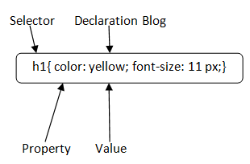
Selector:
Selector indicates the HTML element you want to style. It could be any tag like <h1>, <title> etc.
Declaration Block:
The declaration block can contain one or more declarations separated by a semicolon. For the above example, there are two declarations:
- color: yellow;
- font-size: 11 px;
Each declaration contains a property name and value, separated by a colon.
Property:
A Property is a type of attribute of HTML element. It could be color, border etc.
Value:
Values are assigned to CSS properties. In the above example, value "yellow" is assigned to color property.
Selector{Property1: value1; Property2: value2; ..........;}

CSS Colors
- The color property in CSS is used to set the color of HTML elements. Typically, this property is used to set the background color or the font color of an element.
- In CSS, we use color values for specifying the color. We can also use this property for the border-color and other decorative effects.
- We can define the color of an element by using the following ways:
- RGB format.
- RGBA format.
- Hexadecimal notation.
- HSL.
- HSLA.
- Built-in color.

RGB Format
- RGB format is the short form of 'RED GREEN and BLUE' that is used for defining the color of an HTML element simply by specifying the values of R, G, B that are in the range of 0 to 255.
- The color values in this format are specified by using the rgb() property. This property allows three values that can either be in percentage or integer (range from 0 to 255).
- This property is not supported in all browsers; that's why it is not recommended to use it.
Syn: color: rgb(R, G, B);

RGBA Format
- It is almost similar to RGB format except that RGBA contains A (Alpha) that specifies the element's transparency. The value of alpha is in the range 0.0 to 1.0, in which 0.0 is for fully transparent, and 1.0 is for not transparent.
Syn: color:rgba(R, G, B, A);

Hexadecimal notation
- Hexadecimal can be defined as a six-digit color representation.
- This notation starts with the # symbol followed by six characters ranges from 0 to F.
- In hexadecimal notation, the first two digits represent the red (RR) color value, the next two digits represent the green (GG) color value, and the last two digits represent the blue (BB) color value.
- The black color notation in hexadecimal is #000000, and the white color notation in hexadecimal is #FFFFFF. Some of the codes in hexadecimal notation are #FF0000, #00FF00, #0000FF, #FFFF00, and many more.
Syn: color:#(0-F)(0-F)(0-F)(0-F)(0-F)(0-F);

Short Hex codes
- It is a short form of hexadecimal notation in which every digit is recreated to arrive at an equivalent hexadecimal value.
- For example, #7B6 becomes #77BB66 in hexadecimal.
- The black color notation in short hex is #000, and the white color notation in short hex is #FFF. Some of the codes in short hex are #F00, #0F0, #0FF, #FF0, and many more.

HSL
- It is a short form of Hue, Saturation, and Lightness.
  - Hue:
It can be defined as the degree on the color wheel from 0 to 360. 0 represents red, 120 represents green, 240 represents blue.
  - Saturation:
It takes value in percentage in which 100% represents fully saturated, i.e., no shades of gray, 50% represent 50% gray, but the color is still visible, and 0% represents fully unsaturated, i.e., completely gray, and the color is invisible.
  - Lightness:
The lightness of the color can be defined as the light that we want to provide the color in which 0% represents black (there is no light), 50% represents neither dark nor light, and 100% represents white (full lightness).
Syn: color:hsl(H, S, L);

HSLA
- It is entirely similar to HSL property, except that it contains A (alpha) that specifies the element's transparency. The value of alpha is in the range 0.0 to 1.0, in which 0.0 indicates fully transparent, and 1.0 indicates not transparent.
Syn: color:hsla(H, S, L, A);

Built-in Color
As its name implies, built-in color means the collection of previously defined colors that are used by using a name such as red, blue, green, etc.
Syn: color: color-name;
S.no. | Color name | Hexadecimal Value | Decimal Value or rgb() value
1. | Red | #FF0000 | rgb(255,0,0)
2. | Orange | #FFA500 | rgb(255,165,0)
3. | Yellow | #FFFF00 | rgb(255,255,0)
4. | Pink | #FFC0CB | rgb(255,192,203)
5. | Green | #008000 | rgb(0,128,0)
6. | Violet | #EE82EE | rgb(238,130,238)
7. | Blue | #0000FF | rgb(0,0,255)
8. | Aqua | #00FFFF | rgb(0,255,255)
9. | Brown | #A52A2A | rgb(165,42,42)
10. | White | #FFFFFF | rgb(255,255,255)
11. | Gray | #808080 | rgb(128,128,128)
12. | Black | #000000 | rgb(0,0,0)

Example
<html>
<head> <title>CSS hsl color property</title>
<style>
h1{ text-align:center; }
#rgb{ color:rgb(255,0,0); }
#rgba{color:rgba(255,0,0,0.5); }
#hex{ color:#EE82EE; }
#short{color: #E8E; }
#hsl{ color:hsl(0,50%,50%); }
#hsla{ color:hsla(0,50%,50%,0.5); }
#built{ color:green; }
</style> </head>
<body>
<h1 id="rgb"> Hello World. This is RGB format. </h1>
<h1 id="rgba"> Hello World. This is RGBA format. </h1>
<h1 id="hex">Hello World. This is Hexadecimal format. </h1>
<h1 id="short">Hello World. This is Short-hexadecimal format. </h1>
<h1 id="hsl"> Hello World. This is HSL format. </h1>
<h1 id="hsla"> Hello World. This is HSLA format. </h1>
<h1 id="built"> Hello World. This is Built-in color format. </h1>
</body>
</html>

CSS Background
CSS background property is used to define the background effects on element. There are 5 CSS background properties that affects the HTML elements:
- background-color
- background-image
- background-repeat
- background-attachment
- background-position

S.No. | Property | Description
1 | background-color | The background-color property is used to specify the background color of the element.
2 | background-image | The background-image property is used to set an image as a background of an element. By default the image covers the entire element. You can set the background image for a page like this.
3 | background-repeat | By default, the background-image property repeats the background image horizontally and vertically. Some images are repeated only horizontally or vertically.  The background looks better if the image repeated horizontally only.
4 | background-attachment | The background-attachment property is used to specify if the background image is fixed or scroll with the rest of the page in browser window. If you set fixed the background image then the image will not move during scrolling in the browser.
5 | background-position | The background-position property is used to define the initial position of the background image. By default, the background image is placed on the top-left of the webpage.  You can set the following positions:  - center  - top  - bottom  - left  - right
Eg for background-color
<html>
<head>
<style>
h2,p{ background-color: #b0d4de; }
</style>
</head>
<body>
<h2>My first CSS page.</h2>
<p>Hello Future Software. This is an example of CSS background-color.</p>
</body>
</html>
Eg for background-image
<html>
<head>
<style>
body { background-image: url("paper1.gif"); margin-left:100px; }
</style>
</head>
<body>
<h1>Hello Futuresolutions.com</h1>
</body> </html>

CSS Border
- The CSS border is a shorthand property used to set the border on an element.
- The CSS border properties are use to specify the style, color and size of the border of an element. The CSS border properties are given below
S.No. | Property | Description
1 | border-style | The Border style property is used to specify the border type which you want to display on the web page.  There are some border style values which are used with border-style property to define a border. They are none, dotted, dashed, solid, double, groove, ridge, inset, outset
2 | border-color | There are three methods to set the color of the border.  - Name: It specifies the color name. For example: "red".  - RGB: It specifies the RGB value of the color. For example: "rgb(255,0,0)".  - Hex: It specifies the hex value of the color. For example: "#ff0000".  There is also a border color named "transparent". If the border color is not set it is inherited from the color property of the element.
3 | border-width | The border-width property is used to set the border's width. It is set in pixels. You can also use the one of the three pre-defined values, thin, medium or thick to set the width of the border.
Eg:
<html>
<head>
<style>
p.none {border-style: none;}
p.dotted {border-style: dotted;}
p.dashed {border-style: dashed;}
p.solid {border-style: solid;}
p.double {border-style: double;}
p.groove {border-style: groove;}
p.ridge {border-style: ridge;}
p.inset {border-style: inset;}
p.outset {border-style: outset;}
p.hidden {border-style: hidden;}
</style>
</head>
<body>
<p class="none">No border.</p>
<p class="dotted">A dotted border.</p>
<p class="dashed">A dashed border.</p>
<p class="solid">A solid border.</p>
<p class="double">A double border.</p>
<p class="groove">A groove border.</p>
<p class="ridge">A ridge border.</p>
<p class="inset">An inset border.</p>
<p class="outset">An outset border.</p>
<p class="hidden">A hidden border.</p> </body> </html>

CSS Margin
- CSS Margin property is used to define the space around elements. It is completely transparent and doesn't have any background color. It clears an area around the element.
- Top, bottom, left and right margin can be changed independently using separate properties. You can also change all properties at once by using shorthand margin property.
- There are following CSS margin properties:
Property | Description
margin | This property is used to set all the properties in one declaration.
margin-left | it is used to set left margin of an element.
margin-right | It is used to set right margin of an element.
margin-top | It is used to set top margin of an element.
margin-bottom | It is used to set bottom margin of an element.

CSS Margin Values
These are some possible values for margin property.
Value | Description
Auto | This is used to let the browser calculate a margin.
Length | It is used to specify a margin pt, px, cm, etc. its default value is 0px.
% | It is used to define a margin in percent of the width of containing element.
Inherit | It is used to inherit margin from parent element.

Eg
<html>
<head>
<style>
p { background-color: pink; }
p.ex {
margin-top: 50px;
margin-bottom: 50px;
margin-right: 100px;
margin-left: 100px;
} </style></head>
<body>
<p>This paragraph is not displayed with specified margin. </p>
<p class="ex">This paragraph is displayed with specified margin.</p>
</body> </html>

Margin: Shorthand Property
- CSS shorthand property is used to shorten the code. It specifies all the margin properties in one property.
- There are four types to specify the margin property. You can use one of them.
- margin: 50px 100px 150px 200px;
- margin: 50px 100px 150px;
- margin: 50px 100px;
- margin 50px;

1) margin: 50px 100px 150px 200px;
It identifies that:
- top margin value is 50px
- right margin value is 100px
- bottom margin value is 150px
- left margin value is 200px
Eg:
<html> <head>
<style>
p { background-color: pink; }
p.ex { margin: 50px 100px 150px 200px; }
</style> </head>
<body>
<p>This paragraph is not displayed with specified margin. </p>
<p class="ex">This paragraph is displayed with specified margin.</p>
</body>
</html>

2) margin: 50px 100px 150px;
It identifies that:
- top margin value is 50px
- left and right margin values are 100px
- bottom margin value is 150px
Eg:
<html> <head>
<style>
p { background-color: pink; }
p.ex { margin: 50px 100px 150px; }
</style> </head>
<body>
<p>This paragraph is not displayed with specified margin. </p>
<p class="ex">This paragraph is displayed with specified margin.</p>
</body> </html>

3) margin: 50px 100px;
It identifies that:
- top and bottom margin values are 50px
- left and right margin values are 100px
eg:<html>
<head> <style>
p { background-color: pink; }
p.ex { margin: 50px 100px; }
</style> </head>
<body>
<p>This paragraph is not displayed with specified margin. </p>
<p class="ex">This paragraph is displayed with specified margin.</p>
</body> </html>

4) margin: 50px;
It identifies that:
- top right bottom and left margin values are 50px
Eg:
<html>
<head>
<style>
p { background-color: pink; }
p.ex { margin: 50px; }
</style> </head>
<body>
<p>This paragraph is not displayed with specified margin. </p>
<p class="ex">This paragraph is displayed with specified margin.</p>
</body> </html>

CSS Padding
- CSS Padding property is used to define the space between the element content and the element border.
- It is different from CSS margin in the way that CSS margin defines the space around elements. CSS padding is affected by the background colors. It clears an area around the content.
- Top, bottom, left and right padding can be changed independently using separate properties. You can also change all properties at once by using shorthand padding property.

CSS Padding Properties
Property | Description
padding | It is used to set all the padding properties in one declaration.
padding-left | It is used to set left padding of an element.
padding-right | It is used to set right padding of an element.
padding-top | It is used to set top padding of an element.
padding-bottom | It is used to set bottom padding of an element.

CSS Padding Values
Value | Description
Length | It is used to define fixed padding in pt, px, em etc.
% | It defines padding in % of containing element.

CSS height property
- This CSS property sets the height of an element. It is used to set the height of content area of an element.
- It does not include padding borders or margins, whereas it sets the height of the area inside the padding, border, and margin of the element. It can accept the length and percentage values. But it does not allow negative values.
- If we set the height to a numeric value (like in px, %, etc.), the content can be overflow if it does not fit in the given height. We can manage the overflowing content by defining the overflow property.
- If the height of the container is not explicitly defined, and the element is not absolutely positioned (i.e., position: absolute;), the value of height property is set to auto. The min-height and max-height properties can also be used to control the size.

Syn:height: auto | length | initial | inherit;

Property Values
The values of this property are tabulated as follows.
Value |  | Description
Auto | It is a default value. Using this value browser is responsible for calculating the height of the element. Negative values are not allowed.
Length | It specifies the height of an element using the length units such as px, cm, pt, etc. Negative values are not allowed.
% | It defines the height of the container in %. Negative values are not allowed.
Initial | It is used to set the property to its default value.
Inherit | It is used to inherit the property from its parent element.

Eg:
<html> <head>
<style>
#auto{
height: auto;
width: 275px;
border: 2px solid blue;
}
#px{
height: 320px;
width: 275px;
border: 2px solid blue; }
#em{
height: 16em;
width: 275px;
border: 2px solid blue;
}
p{ font-size: 20px; }
</style>
</head>
<body>
<h2> height: auto; </h2>
<div id ="auto">
<img src="jtp.png">
<p> Welcome to the Futuresolutions.com </p>
<p> The height this div element is set to auto. </p> </div>
<h2> height: 320px; </h2>
<div id ="px">
<img src="jtp.png">
<p> Welcome to the FutureSolutions.com </p>
<p> The height this div element is set to 320px. </p>
</div><br>
<h2> height: 16em; </h2>
<div id ="em">
<img src="jtp.png">
<p> Welcome to FutureSolutions.com </p>
<p> The height this div element is set to 16em. </p>
</div>
</body>
</html>

CSS Width
- The CSS width property is used to set the width of the content area of an element.
- It does not include padding borders or margins. It sets width of the area inside the padding, border, and margin of the element.
Value | Description
Auto | It is a default value. it is used to calculate the width.
length | It is used to define the width in px, cm etc.
% | It defines the width of the containing block in %.
Initial | It is used to set the property to its default value.
Inherit | It is used to inherit the property from its parent element.

Eg:<html>
<head> <style>
img.normal { width: auto; }
img.big { width: 150px; }
p.ex { height: 150px; width: 150px; }
</style> </head>
<body>
<img class="normal" src="good-morning.jpg" width="95" height="84"><br>
<img class="big" src="good-morning.jpg" width="95" height="84">
<p class="ex">The height and width of this paragraph is 150px.</p>
<p>This is a paragraph.</p>
</body>
</html>

CSS Text
Property | Description
Text-indent | This property indents the first line of text in a block.
Text-align | The property controls the alignment of the text. It can have values of left, right, center, justify.
Line-height | This property is part of the font property. This specifies the line spacing for multiple lines of text.
Text-decoration | The text-decoration property is used to define an effect on text. The standard values for this property include blink, line-through, overline, underline and none. The “none” property is often used with <A> tag to disable the underline in the hyperlink.
Text-transform | This determines the capitalization of the text it affects. The possible values for this property are capitalize, uppercase, lowercase and none. Capitalize will make the initial letter of each word a capital.
Letter-spacing | This property specifies the amount of space between letters. The default property normal uses the browser’s default letter spacing. You can use em, px, pt or cm as measurements.
Word-spacing | This property specifies the amount of space between words. The default value is normal, uses the browser’s default word spacing. You can include measurements similar to letter-spacing. At the time of this write-up major browsers do not support the word spacing.
Vertical-align | This property lets you position content vertically within a block. The property can accept following values baseline, sub, super, top, middle, bottom. Normally this property is used with the table cells.
White-space | To control the white space in the page, use this property. This property lets you specify normal, pre, nowrap values. Normal is the default and collapses all whitespace and break lines to fit within the given block. Pre maintains the text as it is typed, recognizing tabs, extra spaces and line breaks. Nowrap acts like normal but does not add line breaks to fit in the given block

CSS Font
CSS Font property is used to control the look of texts. By the use of CSS font property you can change the text size, color, style and more. You have already studied how to make text bold or underlined. Here, you will also know how to resize your font using percentage. These are some important font attributes:
- CSS Font color: This property is used to change the color of the text. (standalone attribute)
- CSS Font family: This property is used to change the face of the font.
- CSS Font size: This property is used to increase or decrease the size of the font.
- CSS Font style: This property is used to make the font bold, italic or oblique.
- CSS Font variant: This property creates a small-caps effect.
- CSS Font weight: This property is used to increase or decrease the boldness and lightness of the font.

CSS icons
- Icons can be defined as the images or symbols used in any computer interface refer to an element. It is a graphical representation of a file or program that helps the user to identify about the type of file quickly.
- Using the icon library is the easiest way to add icons to our HTML page. It is possible to format the library icons by using CSS. We can customize the icons according to their color, shadow, size, etc.
- There are given some of the icon libraries such as Bootstrap icons, Font Awesome icons, and Google icons that can be used in CSS easily. There is no need to install or download the libraries mentioned above.

CSS Lists
There are various CSS properties that can be used to control lists. Lists can be classified as ordered lists and unordered lists. In ordered lists, marking of the list items is with alphabet and numbers, whereas in unordered lists, the list items are marked using bullets. We can style the lists using CSS. CSS list properties allow us to:
- Set the distance between the text and the marker in the list.
- Specify an image for the marker instead of using the number or bullet point.
- Control the marker appearance and shape.
- Place the marker outside or inside the box that contains the list items.
- Set the background colors to list items and lists.
The CSS properties to style the lists are given as follows:

The list-style-type property
It allows us to change the default list type of marker to any other type such as square, circle, roman numerals, Latin letters, and many more. By default, the ordered list items are numbered with Arabic numerals (1, 2, 3, etc.), and the items in an unordered list are marked with round bullets (•).
If we set its value to none, it will remove the markers/bullets.

Eg
<html>
<head>
<title>CSS Lists</title>
<style>
.num{ list-style-type:decimal; }
.alpha{ list-style-type:lower-alpha; }
.roman{ list-style-type:lower-roman; }
.circle{ list-style-type:circle; }
.square{ list-style-type:square; }
.disc{ list-style-type:disc; }
</style>
</head>
<body>
<h1> Welcome to the Futuresolutions.com </h1>
<h2> Ordered Lists </h2>
<ol class="num">
<li>one</li>
<li>two</li>
<li>three</li>
</ol>
<ol class="alpha">
<li>one</li>
<li>two</li>
<li>three</li>
</ol>
<ol class="roman">
<li>one</li>
<li>two</li>
<li>three</li>
</ol>
<h2> Unordered lists </h2>
<ul class="disc">
<li>one</li>
<li>two</li>
<li>three</li>
</ul>
<ul class="circle">
<li>one</li>
<li>two</li>
<li>three</li>
</ul>
<ul class="square">
<li>one</li>
<li>two</li>
<li>three</li>
</ul>
</body>
</html>

The list-style-position property
- It represents whether the appearing of the marker is inside or outside of the box containing the bullet points. It includes two values.
- inside: It means that the bullet points will be in the list item. In this, if the text goes on the second line, then the text will be wrap under the marker.
- outside: It represents that the bullet points will be outside the list item. It is the default value.

Eg:
<html>
<head> <title>CSS Lists</title>
<style>
.num{ list-style-type:decimal; list-style-position:inside; }
.roman{ list-style-type:lower-roman; list-style-position:outside; }
.circle{ list-style-type:circle; list-style-position:inside; }
.square{ list-style-type:square; }
.disc{ list-style-type:disc; list-style-position:inside; }
</style>
</head>
<body>
<h1> Welcome to the Futuresolutions.com </h1>
<h2> Ordered Lists </h2>
<ol class="num">
<li>INSIDE</li>
<li>two</li>
<li>three</li>
</ol>
<ol class="roman">
<li>OUTSIDE</li>
<li>two</li>
<li>three</li> </ol>
<h2> Unordered lists </h2>
<ul class="disc">
<li>INSIDE</li>
<li>two</li>
<li>three</li>
</ul>
<ul class="circle">
<li>INSIDE</li>
<li>two</li>
<li>three</li>
</ul>
<ul class="square">
<li>DEFAULT</li>
<li>two</li>
<li>three</li>
</ul>
</body>
</html>

The list-style-image property
It specifies an image as the marker. Using this property, we can set the image bullets. Its syntax is similar to the background-image property. If it does not find the corresponding image, the default bullets will be used.

Eg
<html>
<head>
<title>CSS Lists</title>
<style>
.order{ list-style-image: url(img.png); }
.unorder{ list-style-image: url(img.png); }
/style>
</head>
<body>
<h1> Welcome to the Futuresolutions.com </h1>
<h2> Ordered Lists </h2>
<ol class="order">
<li>one</li>
<li>two</li>
<li>three</li>
</ol>
<h2> Unordered lists </h2>
<ul class="unorder">
<li>one</li>
<li>two</li>
<li>three</li>
</ul>
</body>
</html>

The list-style property
It is the shorthand property that is used to set all list properties in one expression. The order of the values of this property is type, position, and image. But if any property value is missing, then the default value will be inserted.

Eg
<html>
<head>
<title>CSS Lists</title>
<style>
.order{ list-style: lower-alpha inside url(img.png); }
.unorder{ list-style: disc outside; }
</style>
</head>
<body>
<h1> Welcome to the Futuresolutions.com </h1>
<h2> Ordered Lists </h2>
<ol class="order">
<li>one</li>
<li>two</li>
<li>three</li>
</ol>
<h2> Unordered lists </h2>
<ul class="unorder">
<li>one</li>
<li>two</li>
<li>three</li>
</ul>
</body>
</html>

Styling Lists with colors
To make the lists more attractive and interesting, we can style lists with colors. The addition of anything to the <ul> or <ol> tag will affect the entire list, whereas the addition to the individual <li> tag will affect the items of the corresponding list.

Eg:
<html>
<head>
<title>CSS Lists</title>
<style>
.order{ list-style: upper-alpha; background: pink; padding:20px; }
.order li{ background: lightblue; padding:10px; font-size:20px; margin:10px; }
.unorder{ list-style: square inside; background: cyan; padding:20px; }
.unorder li{ background: green; color:white; padding:10px; font-size:20px;
margin:10px; }
</style>
</head>
<body>
<h1> Welcome to the Futuresolutions.com </h1>
<h2> Ordered Lists </h2>
<ol class="order">
<li>ONE</li>
<li>TWO</li>
<li>THREE</li>
</ol>
<h2> Unordered lists </h2>
<ul class="unorder">
<li>ONE</li>
<li>TWO</li>
<li>THREE</li>
</ul>
</body> </html>

CSS Table
We can apply style on HTML tables for better look and feel. There are some CSS properties that are widely used in designing table using CSS:
- border
- border-collapse
- padding
- width
- height
- text-align
- color
- background-color

CSS Table Border
We can set border for the table, th and td tags using the CSS border property.
<style>
table, th, td { border: 1px solid black; }
</style>

CSS Table Border Collapse
By the help of border-collapse property, we can collapse all borders in one border only.
<style>
table, th, td
{
border: 2px solid black;
border-collapse: collapse;
}
</style>

CSS Table Padding
We can specify padding for table header and table data using the CSS padding property.
<style>
table, th, td {
border: 1px solid black;
border-collapse: collapse;
}
th, td
{ padding: 10px; }
</style>

CSS Table: Styling even and odd cells
We can style even and odd table cells for better look and feel. In this code, we are displaying different background colors on even and odd cells. Moreover, we have changed the background-color and color of <th> tag.
<style>
table, th, td {
border: 1px solid black;
border-collapse: collapse;
}
th, td { padding: 10px; }
table#alter tr:nth-child(even) {
background-color: #eee;
}
table#alter tr:nth-child(odd) {
background-color: #fff;
}
table#alter th {
color: white;
background-color: gray;
}
</style>

CSS Counters
- CSS counters are similar to variables. These are maintained by CSS and those values can be incremented by CSS rules to track how many times they are used.
- CSS counters facilitate simple CSS based incrementing and display of a number for generated content.
- Following is a list of properties that are used with CSS counter:
- counter-reset: It is used to create or reset a counter.
- counter-increment: It is used to increment the counter value.
- content: It is used to insert generated content.
- counter() or counters() function: It is used to add the value of a counter to an element.

Eg:
<html>
<head>
<style>
body { counter-reset: section; }
h2::before { counter-increment: section;
content: "Section " counter(section) ": "; }
</style> </head>
<body> <h1>Example of CSS Counters:</h1>
<h2>Java Tutorial</h2>
<h2>HTML Tutorial</h2>
<h2>CSS Tutorial</h2>
<h2>Oracle Tutorial</h2>
<p><strong>Note:</strong> IE8 supports these properties only if a !DOCTYPE is specified.</p> </body> </html>
CSS Nesting Counters
You can also create counters within the counter. It is called nesting of a counter. Let's take an example to demonstrate nesting counter.
See this example:
<html>
<head>
<style>
body { counter-reset: section; }
h1 { counter-reset: subsection; }
h1::before { counter-increment: section;
content: "Section " counter(section) ". ";
}
h2::before {
counter-increment: subsection;
content: counter(section) "." counter(subsection) " "; }
</style> </head>
<body>
<h1>Java tutorials:</h1>
<h2>Core Java tutorial</h2>
<h2>Servlet tutorial</h2>
<h2>JSP tutorial</h2>
<h2>Spring tutorial</h2>
<h2>Hibernate tutorial</h2>
<h1>Web technology tutorials:</h1>
<h2>HTML tutorial</h2>
<h2>CSS tutorial</h2>
<h2>jQuery tutorial</h2>
<h2>Bootstrap tutorial</h2>
<h1>Database tutorials:</h1>
<p><strong>Note:</strong> IE8 supports these properties only if a !DOCTYPE is specified.</p>
</body>
</html>

UNIT – III
DHTML
- DHTML stands for Dynamic Hypertext Markup language i.e., Dynamic HTML.
- Dynamic HTML is not a markup or programming language but it is a term that combines the features of various web development technologies for creating the web pages dynamic and interactive.
- The DHTML application was introduced by Microsoft with the release of the 4th version of IE (Internet Explorer) in 1997.

Components of Dynamic HTML
DHTML consists of the following four components or languages:
- HTML 4.0
HTML is a client-side markup language, which is a core component of the DHTML. It defines the structure of a web page with various defined basic elements or tags.
- CSS
CSS stands for Cascading Style Sheet, which allows the web users or developers for controlling the style and layout of the HTML elements on the web pages.
- JavaScript
JavaScript is a scripting language which is done on a client-side. The various browser supports JavaScript technology. DHTML uses the JavaScript technology for accessing, controlling, and manipulating the HTML elements. The statements in JavaScript are the commands which tell the browser for performing an action.
- DOM
DOM is the document object model. It is a w3c standard, which is a standard interface of programming for HTML. It is mainly used for defining the objects and properties of all elements in HTML.

JavaScript
- JavaScript is an interpreted language used primarily to enhance look of your web site. Instead of storing itself as a separate file it is included as a part of the standard HTML document. Among one of the many notable features JavaScript has, one is that it integrates itself with OOP.
- JavaScript programs can be run either on a web server or web browser, depending upon your needs and requirements. Its ability to integrate itself and to modify and manipulate the contents of a web page dynamically makes it ideally suited to web publishing.
Advantages:
- Javascript is supported by most of the web browsers
- It provides an easy way of accessing document objects as well as it can manipulate almost all of these objects
- It gives attractive animations with a less download time for the multimedia datatypes
- No special plug ins are required to use javascripts.
- Security is the biggest advantage of javascript. Because javascript can’t read from/write to the local hard drive and the system can’t get a virus directly from javascript.

Disadvantages:
- A page becomes useless if the script is not working
- Most of the web surfers disable their javascript support due to the problems associated with broken scripts
- Complex scripts take longer starting and running time.
- Most of the Javascripts depend on the manipulation of DOM’s elements and different browsers given different type of accessing to objects.
Data types of Javascript
- JavaScript is a dynamic type language, means you don't need to specify type of the variable because it is dynamically used by JavaScript engine. You need to use var here to specify the data type. It can hold any type of values such as numbers, strings etc.
- JavaScript provides different data types to hold different types of values. There are two types of data types in JavaScript.
- Primitive data type
- Non-primitive (reference) data type

JavaScript primitive data types
There are five types of primitive data types in JavaScript. They are as follows:
Data Type | Description
String | represents sequence of characters e.g. "hello"
Number | represents numeric values e.g. 100
Boolean | represents boolean value either false or true
Undefined | represents undefined value
Null | represents null i.e. no value at all

JavaScript non-primitive data types
The non-primitive data types are as follows:
Data Type | Description
Object | represents instance through which we can access members
Array | represents group of similar values
RegExp | represents regular expression

Variable
A JavaScript variable is simply a name of storage location where values can be constantly changed during run time of a program.To define variables the following rules to be followed.
- The variable name cannot be reserved word.
- The first character in the name must be an alphabetic letter or an underscore or dollar( $ ) sign
- Characters subsequent to the first character in the variable name can be alphabetic letters, numbers or underscores.
- Duplicate variable names cannot be defined.

Types of Variables:
There are two types of variables in JavaScript
- Local variable and
- Global variable.

JavaScript local variable
- A JavaScript local variable is declared inside block or function.
- It is accessible within the function or block only
Eg: <script>
function abc()
{ var x=10;//local variable }
</script>

JavaScript global variable
- A JavaScript global variable is accessible from any function.
- A variable i.e. declared outside the function or declared with window object is known as global variable.
Eg:
<script>
var data=200;//gloabal variable
function a(){
document.writeln(data);
}
function b(){
document.writeln(data);
}
a();//calling JavaScript function
b();
</script>
Operators of Javascript
An operator is nothing but symbols which are used to operate the operands. The operators are
- Arithmetic operators
- Relational / Comparison operators
- Logical Operators
- Assignment Operators
- Bitwise Logical Operators
- Unary operators
Arithmetic Operators:
The arithmetic operators are used to perform arithmetic operations, Such as addition, Subtraction, multiplication and division. The arithmetic operators are
Operator | Meaning
+ | Addition
- | Subtraction
* | Multiplication
/ | Division
% | Modulus
Relational / Comparison Operators:
The Relational operators are used to compare the operands. The relational operators are
Operator | Meaning
> | Greater than
< | Less than
>= | Greater than equals to
<= | Less than equals to
== | equals to
!= | Not equals to
Assignment Operators:
The assignment operators are used to assign R.H.S value to L.H.S. before calculation or after calculation.
Operator | Meaning
= | Assigns RHS value to LHS
+= | Assigns RHS value to LHS after addition
-= | Assigns RHS value to LHS after subtraction
*= | Assigns RHS value to LHS after multiplication
/= | Assigns RHS value to LHS after Division
%= | Assigns RHS value to LHS after modulus
Logical Operators:
The logical operators are used to combine two or more expressions into one. The logical operators are
Operator | Meaning
&& | And
|| | Or
Unary Operator:
The unary operators are used to perform unary calculations such as incrementation and decrementation. The incrementation can be post incrementation or pre incrementation and the decrementation can be post-decrementation or pre-decrementation. The unary operators are
Operator | Meaning
++ | Incrementation
-- | Decrementation
Control Statements
- Conditional statements
- Iterative Statements
Conditional Statements
The Conditional statements are used to control the flow of execution of statements of program. Javascript support different types of conditional statements. They are
- Simple If
- If…Else
- If…Else If
- Nested if
- switch
If statement
This conditional statement is used to execute true statements only when the condition is true otherwise it skips the if statement.
Syn: if (condition)
{
lines of code to be executed if condition is true
}
if…else statement
This conditional statement is used to execute true statements only when the condition is true otherwise it executes the false statements.
Syn: if (condition)
{
lines of code to be executed if the condition is true
}
else
{
lines of code to be executed if the condition is false
}
Eg:
<html>
<head><title>If...Else Statments!!!</title>
<script type="text/javascript">
var hours = new Date().getHours();
if(hours<12)
document.write("Good Morning!!!<br />");
else
document.write("Good Afternoon!!!<br />");
</script>
</head>
<body>
</body>
</html>
If…Else If statement
This conditional statement is used to execute the statements based on its respective condition. It is also called as branching or ladder statement
Syn:
if (condition1)
{
lines of code to be executed if condition1 is true
}
else if(condition2)
{
lines of code to be executed if condition2 is true
}
else
{
lines of code to be executed if condition1 and condition2 are false
}

Switch
The JavaScript switch statement is used to execute one code from multiple expressions. It is just like else if statement that we have learned in previous page. But it is convenient than if..else..if because it can be used with numbers, characters etc.
Syn: switch(expression)
{
case value1: code to be executed;
break;
case value2: code to be executed;
break;
......
default: code to be executed if above values are not matched;
}

Loops
The JavaScript loops are used to iterate the piece of code using for, while, do while or for-in loops. It makes the code compact. It is mostly used in array. There are four types of loops in JavaScript.
- for loop
- while loop
- do-while loop
- for-in loop

For..loop

The JavaScript for loop iterates the elements for the fixed number of times. It should be used if number of iteration is known.

Syn: for (initialization; condition; increment)
{
code to be executed
}
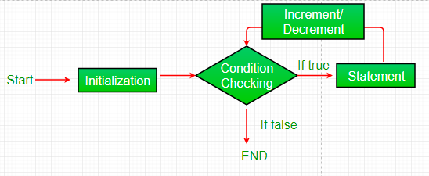
- Initialization condition:
Here, we initialize the variable in use. It marks the start of a for loop. An already declared variable can be used or a variable can be declared, local to loop only.
- Testing Condition:
It is used for testing the exit condition for a loop. It must return a boolean value. It is also an Entry Control Loop as the condition is checked prior to the execution of the loop statements.
- Statement execution:
Once the condition is evaluated to true, the statements in the loop body are executed.
- Increment/ Decrement: It is used for updating the variable for next iteration.
- Loop termination:
When the condition becomes false, the loop terminates marking the end of its life cycle.

Eg:
<script>
for (i=1; i<=5; i++)
document.write(i + "<br/>")
</script>
Output:
1
2
3
4
5
- while loop
A while loop is a control flow statement that allows code to be executed repeatedly based on a given Boolean condition. The while loop can be thought of as a repeating if statement
Syn:
while (condition)
{
code to be executed
}
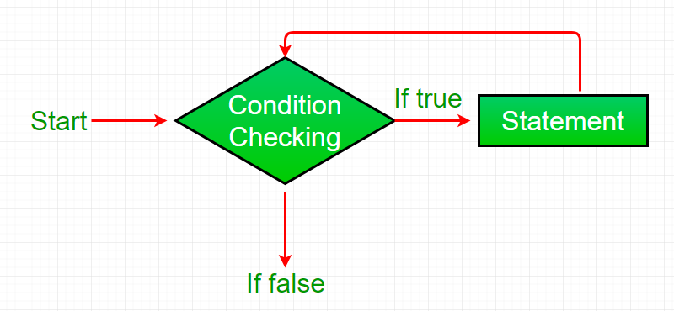
- While loop starts with the checking of condition. If it evaluated to true, then the loop body statements are executed otherwise first statement following the loop is executed. For this reason it is also called Entry control loop
- Once the condition is evaluated to true, the statements in the loop body are executed. Normally the statements contain an update value for the variable being processed for the next iteration.
- When the condition becomes false, the loop terminates which marks the end of its life cycle.
Eg:
<script>
var i=11;
while (i<=15)
{ document.write(i + "");
i++;
}
</script>
Output:
1112131415

- do while loop
The JavaScript do while loop iterates the elements for the infinite number of times like while loop. But, code is executed at least once whether condition is true or false.
Syntax
do
{
code to be executed
}while (condition);

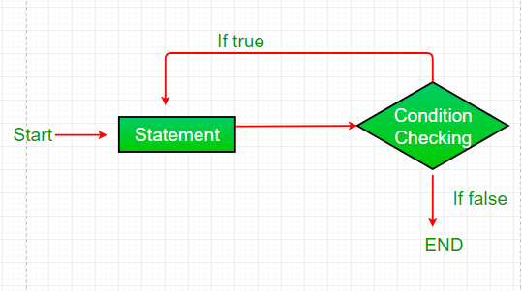
- do while loop starts with the execution of the statement(s). There is no checking of any condition for the first time.
- After the execution of the statements, and update of the variable value, the condition is checked for true or false value. If it is evaluated to true, next iteration of loop starts.
- When the condition becomes false, the loop terminates which marks the end of its life cycle.
- It is important to note that the do-while loop will execute its statements atleast once before any condition is checked, and therefore is an example of exit control loop.
Eg:
<script>
var i=21;
do
{ document.write(i + "");
i++;
}while (i<=25);
</script>
Output:
2122232425
- for in loop
JavaScript also includes another version of for loop also known as the for..in Loops. The for..in loop provides a simpler way to iterate through the properties of an object. This will be more clear after leaning objects in JavaScript. But this loop is seen to be very useful while working with objects.
Syntax: for (variableName in Object)
{
Statement(s)
}
In each iteration, one of the properties of Object is assigned to the variable named variableName and this loop continues until all of the properties of the Object are processed

Eg:
<script type = "text/javaScript">
var languages = { first : "C", second : "Java",
third : "Python", fourth : "PHP",
fifth : "JavaScript" };
for (itr in languages)
{
document.write(languages[itr] + "<br >");
}
< /script>
Arrays
Array is a collection of similar type of elements which can be referred by a command name. Any element in an array is referred by an array name followed by position of an element. The particular position of element in an array is called array index or subscript. Normally the first element in an array is stored at 0th location, however we can start storing the element from any position.

Array Declaration:
In Javascript the array can be created using Array object. Using new operator we can allocate the memory dynamically for the arrays. In the brackets the size of an array is mentioned.
Syntax: Var arrayname=new Array()
Var arrayname=new Array(size)

All the arrays start at the index zero. Array length in JavaScript is not fixed but it can be changed dynamically by assigning values to a new array entries. You can assign values to all its initial elements at the time of array creation. Also JavaScript does not require all entries in an array to share the same data type.
Eg:-1
<script>
var emp=["Sonoo","Vimal","Ratan"];
for (i=0;i<emp.length;i++){
document.write(emp[i] + "<br/>");
}
</script>
Eg-2:
<script>
var i;
var emp = new Array();
emp[0] = "Arun";
emp[1] = "Varun";
emp[2] = "John";
for (i=0;i<emp.length;i++){
document.write(emp[i] + "<br>");
}
</script>
Eg-3:
<script>
var emp=new Array("Jai","Vijay","Smith");
for (i=0;i<emp.length;i++){
document.write(emp[i] + "<br>");
}
</script>

Function
A function is a set of statements that performs some tasks or does some computation and then returns the result to the user.
We can create functions in JavaScript using the keyword function. We can define the function anywhere in the script either in head or body section or in both. But it is a standard practice to define the function in head section and call that function from the body section. The keyword function is used while defining the function.
The idea is to put some commonly or repeatedly done task together and make a function so that instead of writing the same code again and again for different inputs, we can call that function.
Like other programming languages, JavaScript also supports the use of functions. Functions are of 2 types. They are
- Built-in function and
- User-defined functions
Built-in Functions:
The functions which are already existed in Java Script, they are known as pre-defined functions.
Eg: toUpperCase(), toLowerCase(), substring(), concat(), date(), getdate(), getmonth(), etc.,
User-Defined Functions:
The function which creates by the user is called as user-defined functions. The user defined functions can be created by using function keyword.
Rules for creating a function in JavaScript:
- Every function should begin with the keyword function followed by function_name which should be unique,
- A list of parameters enclosed within paranthesis and separated by commas,
- A list of statement composing the body of the function enclosed within curly braces {}.

Syn:
function functionName([arg1, arg2, ...argN])
{
//code to be executed
}
Eg:<html><body>
<script>
function msg()
{ alert("hello! this is message"); }
</script>
<input type="button" onclick="msg()" value="call function"/>
</body></html>

JavaScript Function Arguments
We can call function by passing arguments.
Eg:<html>
<body>
<script>
function getcube(number){ alert(number*number*number); }
</script>
<form>
<input type="button" value="click" onclick="getcube(4)"/></form></body>
</html>

Function with Return Value
We can call function that returns a value and use it in our program.
Eg:
<html>
<body>
<script>
function getInfo()
{
return "hello How r u?";
}
</script>
<script>
document.write(getInfo());
</script></body></html>
    - JavaScript Function Object
In JavaScript, the purpose of Function constructor is to create a new Function object. It executes the code globally. However, if we call the constructor directly, a function is created dynamically but in an unsecured way.
Syntax: new Function ([arg1[, arg2[, ....argn]],] functionBody)
Parameter
- arg1, arg2, .... , argn - It represents the argument used by function.
- functionBody - It represents the function definition.
JavaScript Function Methods
Method | Description
apply() | It is used to call a function contains this value and a single array of arguments.
bind() | It is used to create a new function.
call() | It is used to call a function contains this value and an argument list.
toString() | It returns the result in a form of a string.

Eg-1: Display the sum of given numbers.
<html>
<body>
<script>
var add=new Function("num1","num2","return num1+num2");
document.writeln(add(2,5));
</script>
</body>
</html>

Objects of JavaScript
- A javaScript object is an entity having state and behavior
- JavaScript is an object-based language. Everything is an object in JavaScript.
- JavaScript is template based not class based. Here, we don't create class to get the object. But, we direct create objects.
- JS Array Object
- JS String Object
- JS Date Object
- JS Math Object

JavaScript Array
JavaScript array is an object that represents a collection of similar type of elements. There are 3 ways to construct array in JavaScript
- By array literal
- By creating instance of Array directly (using new keyword)
- By using an Array constructor (using new keyword)

JavaScript array literal
Syn: var arrayname=[value1,value2.....valueN];

As you can see, values are contained inside [ ] and separated by, (comma).The length property returns the length of an array.
Eg:<html>
<body>
<script>
var emp=["Sonoo","Vimal","Ratan"];
for (i=0;i<emp.length;i++)
{document.write(emp[i] + "<br/>"); } </script></body></html>

JavaScript Array directly (new keyword)
Syn:var arrayname=new Array();
Here, new keyword is used to create instance of array.
Eg:
<html>
<body><script>
var i;
var emp = new Array();
emp[0] = "Arun";
emp[1] = "Varun";
emp[2] = "John";
for (i=0;i<emp.length;i++){
document.write(emp[i] + "<br>"); } </script></body></html>

JavaScript array constructor (new keyword)

Here, you need to create instance of array by passing arguments in constructor so that we don't have to provide value explicitly.
Syn:var arrayname=new Array(value1,value2,…….valueN);
Eg:
<html><body><script>
var emp=new Array("Jai","Vijay","Smith");
for (i=0;i<emp.length;i++){
document.write(emp[i] + "<br>");
} </script></body></html>

Array Methods
Methods | Description
concat() | It returns a new array object that contains two or more merged arrays.
fill() | It fills elements into an array with static values.
find() | It returns the value of the first element in the given array that satisfies the specified condition.
indexOf() | It searches the specified element in the given array and returns the index of the first match.
lastIndexOf() | It searches the specified element in the given array and returns the index of the last match.
pop() | It removes and returns the last element of an array.
push() | It adds one or more elements to the end of an array.
reverse() | It reverses the elements of given array.
sort() | It returns the element of the given array in a sorted order.

String Object:
String is a collection of characters. In Java Script using string object many useful string related functionalities can be exposed off. Some commonly used methods of string object are concatenating two strings, converting the string to upper case or lower case, finding the substring of a given string and so on. There are 2 ways to create string in JavaScript
- By string literal
- By string object (using new keyword)

By string literal
The string literal is created using double quotes.
Syn:var stringname="string value"
Eg:
<html><body>
<script>
var str="This is string literal";
document.write(str);
</script></body></html>

By string object (using new keyword)
Syn: var stringname=new String("string literal");
Here, new keyword is used to create instance of string.
Eg:
<html>
<body><script>
var stringname=new String("hello javascript string");
document.write(stringname); </script></body></html>

String Methods
Methods | Description
charAt() | It provides the char value present at the specified index.
concat() | It provides a combination of two or more strings.
indexOf() | It provides the position of a char value present in the given string.
lastIndexOf() | It provides the position of a char value present in the given string by searching a character from the last position.
replace() | It replaces a given string with the specified replacement.
substr() | It is used to fetch the part of the given string on the basis of the specified starting position and length.
substring() | It is used to fetch the part of the given string on the basis of the specified index.
toLowerCase() | It converts the given string into lowercase letter.
toUpperCase() | It converts the given string into uppercase letter.
toString() | It provides a string representing the particular object.
valueOf() | It provides the primitive value of string object.

Date Object
- This object is used for obtaining the date and time. This date and time value is based on computer’s local time or it can be based on GMT. Now a days this GMT is also known as UTC (Universal Co-ordinated Time). This is basically a world time standard.
- The JavaScript date object can be used to get year, month and day. You can display a timer on the webpage by the help of JavaScript date object.
- You can use different Date constructors to create date object. It provides methods to get and set day, month, year, hour, minute and seconds.

Constructor
You can use 4 variant of Date constructor to create date object.
- Date()
- Date(milliseconds)
- Date(dateString)
- Date(year, month, day, hours, minutes, seconds, milliseconds)
Eg:
- var d=new Date();
- var d=new Date(“Month,dd,yyyy”);
- var d=new Date(“Month,dd,yyyyhh:mm:ss”);
- var d=new Date(yy,mm,dd);
- var d=new Date(yy,mm,dd,hh,mm,ss);
Method | Meaning
getTime() | It returns the number of milliseconds. Tis value is the difference between the current time and time value from 1st Jan 1970.
getDate() | Returns the current date based on computers local time
getUTCDate() | Returns the current date obtained from UTC.
getDay() | Returns the current day. The day number is from 0 to 6 i.e. from Sunday to Saturday
getUTCDay() | Returns the current day based on UTC. The day number is from 0 to 6 i.e. from Sunday to Saturday.
getHours() | Returns the hour value ranging from 0 to 23, based on UTC timing zone.
getMilliseconds() | Returns the miliseconds value ranging from 0 to 999, based on local time.
getUTCMilliseconds() | Returns the milliseconds value ranging from 0 to 999, based on UTC timing zone.
getMinutes() | Returns the minute value ranging from 0 to 59, based on local time
getUTCMinutes() | Returns the minute value ranging from 0 to 59, based on UTC timing zone.
getSeconds() | Returns the second value ranging from 0 to 50 based on local time
getUTCSeconds() | Returns the second value ranging from 0 to 59 based on UTC timing zone.
4. Math Object
For performing the mathematical computations there are some useful methods available from math object. Some commonly used methods of math object.
Method | Meaning
Sqrt(n) | This method finds the square root of number
Abs(n) | This method returns absolute value of number
Ceil(n) | This method returns the ceil value of number.
Floor(n) | This method returns the floor value of number.
Pow(a,b) | This method will compute the a and power b.
Min(a,b) | Returns the minimum value of a and b
Max(a,b) | Returns the maximum value of a and b
Sin(n) | Returns the sine of number
Cos(n) | Returns the cosine of number
Tan(n) | Returns the tangent of number
Round(n) | It rounds the value to its nearest integer
Sqrt(n) | It returns the square root of a given number
Regular Expressions
A Regular expression is an object that describes a pattern of characters. Regular expressions are used to perform pattern-matching and “search-and-replace” functions on next. When you search for data in a text, you can use this search pattern to describe what you are searching for.

A regular expression can be a single character, or a more complicated pattern. Regular expressions can be used to perform all types of text search and text replace operations.

Syntax: var txt= new RegExp(pattern, modifiers)
(Or)
var txt=/pattern/modifiers;
- Pattern:A string that specifies the pattern of the regular expression or another regular expression.
- Modifiers:An optional string containing any of the "g", "i", and "m" attributes that specify global, case-insensitive, and multi-line matches, respectively.
Modifier | Description
I | Perform case-insensitive matching
G | Performs a global match (find all matches rather than stopping after the first match)
M | Perform multi-line matching
Brackets:
Brackets ([]) have a special meaning when used in the context of regular expressions. They are used to find a range of characters.
Modifier | Description
[abc] | Find any character between the brackets
[^abc] | Find any character not between the brackets
[0-9] | Find any digit from 0 to 9
[A-Z] | Find any character from uppercase A to uppercase Z
[a-z] | Find any character from lowercase a to lowercase z.
[A-z] | Find any character from uppercase A to lowercase z.
[adgk] | Find any character in the given set
[^adgk] | Find any character outside the given set
(red/blue/green) | Find any of the alternatives specified.
Eg:
<html>
<head>
<title> checker</title>
<script language=”javascript”>
Var s=/^[0-9]{3}[\-]?[0-9]{2}[\-]?[0-9]{4}$/;
function checkSsn(ssn)
{
if(s.test(ssn))
alert(“Valid SSN”);
else
alert(“Invalid SSN”);
}
</script>
</head>
<body><form onsubmit=”return false”>
<input type=text name=”ssn” size=20>
<input type=button value=”Check” onclick=”checkSsn(this.form.ssn.value)”>
</form>
</body>
</html>

Exception Handling
One of the most fascinating features of objected oriented programming languages is “Exception Handling”. In programming aspects “exceptions” refers to run-time errors. Using this concept the errors which may occur during run-time of a given program can be successfully handled, hence the name of the concept.

In terms of object oriented construct, exceptions are taken upon as an object which gets dynamically frames as the code executes. The object accumulates all the errors and also its relative information. Object oriented programming languages privileges users to define separate exception classes which may encompass all the expected exception hence providing fertility to the programming disciplines.
In order to handle the exceptions, we usually report to two important constructs i.e., try..catch() and Throw respectively.
Throw Statement:
Try ..catch() can throw exceptions implicitly, which are later caught by the catch construct provided in the code. But, while using throw statement, it is possible to throw the exception explicitly.

Syntax: Throw ThrowableInstance

The execution procedures follow the normal way till the Throw statement is encountered. The statements following the Throw statement are skipped and the nearest try block is evaluated only if its relative catch block possesses the given type of exception.
Eg:
<HEAD><TITLE>Exception handling</TITLE></HEAD>
<BODY>
<script language="javascript">
var x=prompt("Enter a number between 0 and 5:","")
try
{ if(x>5)
throw "Error1.."
else if(x<5)
throw "Error2..";
}
catch(e)
{ if(e=="Error1..")
alert("Error ! you had entered a large value");
if(e=="Error2..")
alert("Error! Your value is very low");
}
</script></BODY>

UNIT – IV

WordPress
- WordPress is a free and open-source Content Management System (CMS).
- It is an online site based on PHP and MySQL.
- It was mainly designed as a blogging tool but now it has evolved into a versatile CMS. Where, you can use it to create a simple blog as well as a fully operationable website and mobile applications.
- It is even used to create an online store using some WordPress plugins.
- It is considered as the easiest and most popular CMS tool due to its features. The main feature of WordPress is its versatility and feasibility to use. There is no use of coding and designing skills for creating a website on this. Even a non-technical person can also create a website with the help of WordPress easily.
WAMP
- WAMP is an acronym that stands for Windows, Apache, MySQL, and PHP.
- It’s a software stack which means installing WAMP installs Apache, MySQL, and PHP on your operating system.
- WAMP represents as
  - “W” stands for Windows, there’s also LAMP (for Linux) and MAMP (for Mac).
  - “A” stands for Apache. Apache is the server software that is responsible for serving web pages. When you request a page to be seen by you, Apache grants your request over HTTP and shows you the site.
  - “M” stands for MySQL. MySQL’s job is to be the database management system for your server. It stores all of the relevant information like your site’s content, user profiles, etc.
  - “P” stands for PHP. It’s the programming language that was used to write WordPress. It acts like glue for this whole software stack. PHP is running in conjunction with Apache and communicating with MySQL.
Install and Configure WordPress
On local server
To install WordPress on local server you can use software like XAMPP, WAMP and MAMP (for Mac users). These software provide you a server generally Apache, database MySQL on PhpMyAdmin which is required for the installation.
Here, you only have to create a WordPress database using PhpMyAdmin and edit wp config file.

Creating Database
- Open phpmyadmin from the XAMPP server control panel.
- Here, at the top you can see option Databases. Select it.
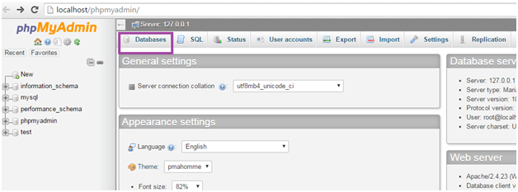
- Look at the above snapshot, click on the Databases above to create a database. You'll be directed to the next window.
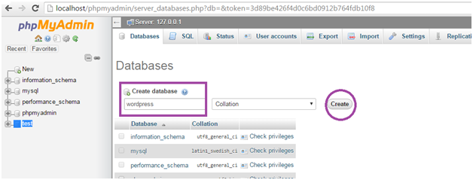
- Look at the above snapshot, you have to create a database to connect with your WordPress. You can name it anything. Here, we have named it as wordpress. Write the database name and click on Create.

Download and Install WordPress
- First you have to download the latest version of WordPress from the official WordPress site www.wordpress.org in your system.
- WordPress will be downloaded in zipped format. This WordPress zipped folder has to be placed in XAMPP folder C:/xampp/htdocs
- Unzip the WordPress folder here and name it anything. Here, we have named it as wordpress.
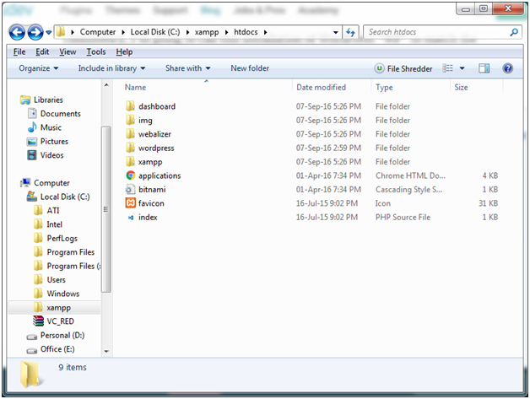
- Open the created wordpress folder. In the folder, find the file wp-config-sample.php file and rename it as wp-config.php file. Scroll down the file untill line number 23 as shown in the below snapshot.
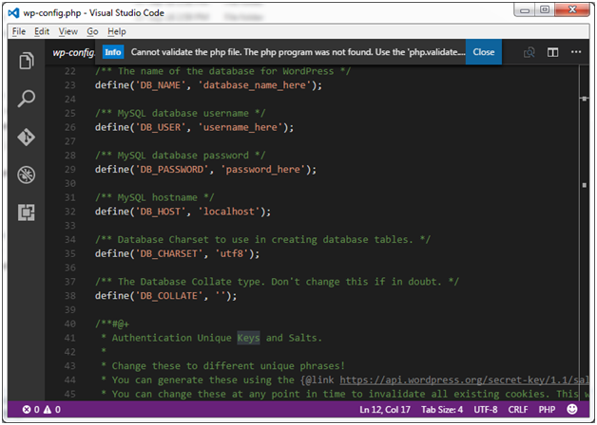
- These lines define the login credentials for your database.
  - Replace "database_name_here" with your database name. In our case it is "wordpress".
  - Replace "username _here" with your "root".
  - "password_here" field will remain blank.
  - Save and close the file.
- Now, open your browser and go to http://localhost/wordpress/
Here, wordpress is the folder name of unzipped WordPress file.
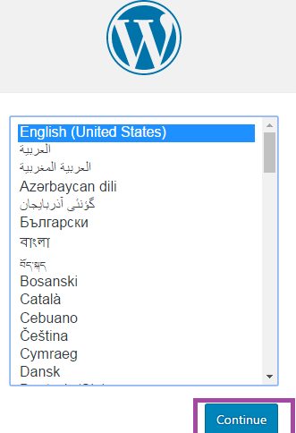
Look at the above snapshot, select your language and click the Continue button.
You'll be directed to the following page.
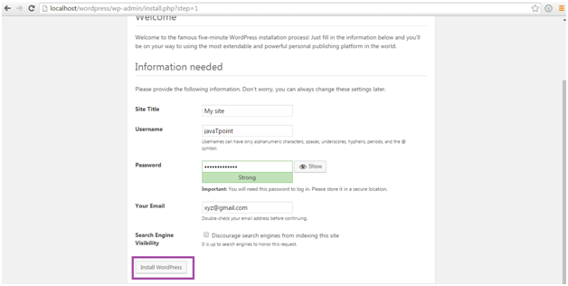
Look at the above snapshot, you have to fill all the details in the fields above and then click Install button.
That's all, you have installed WordPress.
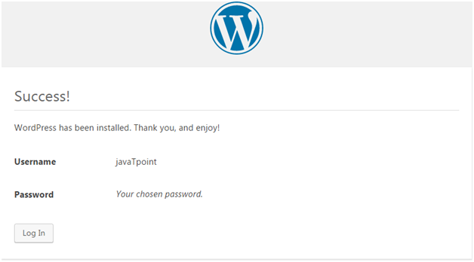

WordPress Dashboard
- WordPress Dashboard allows full access to manage a website behind the scenes. It is the default page in admin panel which comes right after the login page.
- It mainly represents everything that is happening with your blog. You can check everything here related to your post.
- It gives you the updates about your website. If you want to change your password or change any type of setting this is the place where you need to come.
- All the content of dashboard is grouped into widgets. You can be hide/show these widgets as per your requirement. Their positions can also be changed using drag and drop action.
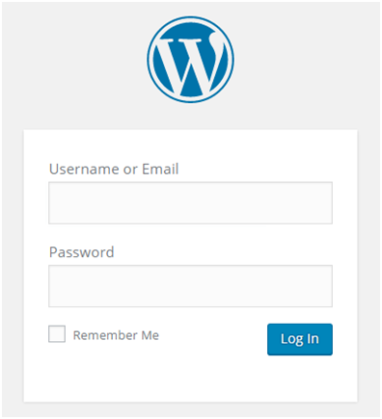
- Look at the above snapshot, this is the login page for WordPress. After filling information click on Log In button, you will be directed to Dashboard screen which is shown below.
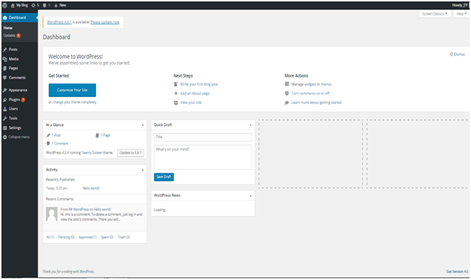
The dashboard of WordPress contains the following components.
- Admin bar
- Sidebar Menu
- Welcome to WordPress
- At a Glance
- Activity
- Quick Draft
- WordPress News
- Screen Options

Admin Bar
- The black bar at the top represents admin bar. It only displays when admin is logged in. That's why this is called admin bar.
- It contains the following items:
- A WordPress icon - It contains information about WordPress, WordPress.org, documentation, etc.
- Home of your site - It brings you to the Home page of your site
- Notifications - All the notifications will be shown here. We have 5 notifications here.
- Comments - Display comments on your blog where you can edit, reply or delete a comment.
- New - You can add up a new page, post, media or user.
- Admin name - It is displayed at the right end of the admin bar showing logged in user name (currently logged in user name is JTP). You can edit your profile and Logout from here.

Sidebar Menu
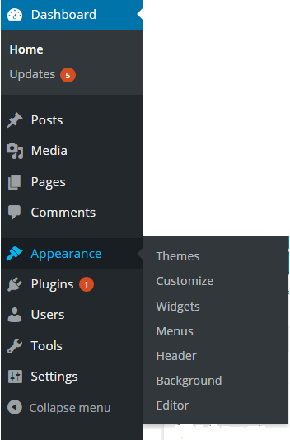
- It is the side menu of the dashboard which contains full menu of options. These options allow easy access to different areas of your site.
- A sub-menu list may appear on selecting an option. Like here we have shown sub-menu list of Appearance.

Menu content:
- Dashboard - Display received updates
- Posts - Manage posts on your blog
- Media - Manage media content library like images, audio and video
- Pages - creating and managing pages
- Comments - display all the comments on your blog
- Appearance - change the appearance of your site
- Plugins - extend capabilities of the website and manage them
- Users - shows all your site's users. Allows editing your site by changing password and name
- Tools - setting of website

Welcome to WordPress
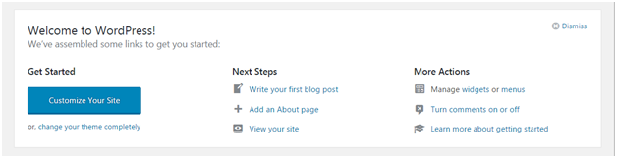
This is displayed at the top middle of the dashboard. There is a button to customize your site using different themes. It contains different links to create blog, view your site and many more as shown above.
There is an option at the top right corner to remove this widget. If you want to remove it you can. But if you want it back, click on screen options drop-down menu.

At a Glance
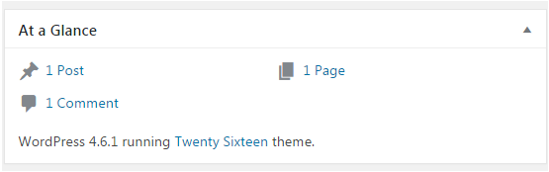
You can have a look on how many posts, pages and comments are there in your site. These comments also include spammed comments. It tells about which theme is currently running on your site.
It also tells about some additional information if some plugins are installed.

Activity
This widget provides you information about some of your recent posts. It displays the recent comment on your post.
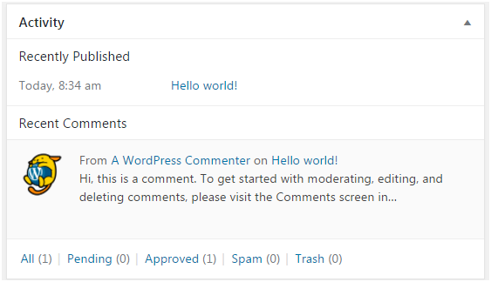
Look at the above snapshot, there is one recent comment in our activity widget.
On doing hover with mouse at a comment, different actions appear below the comment like editing, deleting, replying, etc.
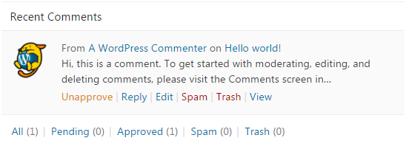

Quick Draft
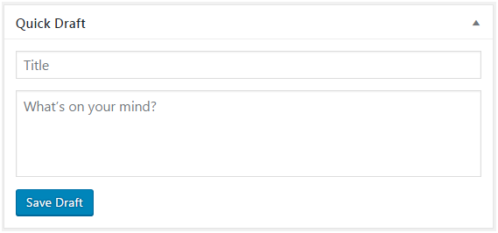
Quick draft widget is a way through which you can write your ideas and save it in a draft form. Later you can write a blog on it.

WordPress Pages
Pages are different from Posts. They are static and they do not change often. Some examples of pages are About, Contact, etc. you can add pages containing information about you and your site.
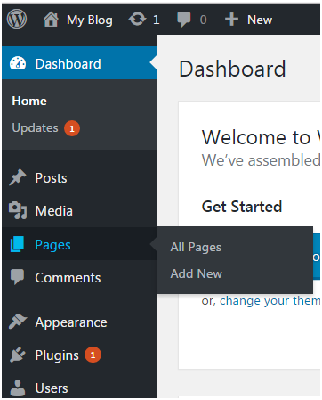

How to Add New Page
Go to Pages > Add New
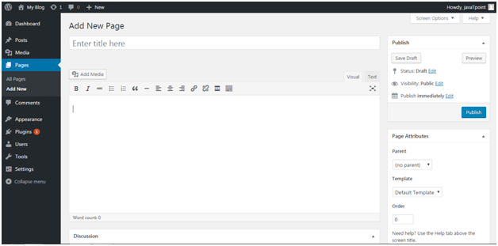
Look at the above snapshot, this is the editorial page where you can give a title and content to your page.
Here you can upload media, write content, add a title to your page. Click on Publish button once you have completed the page.

How to Edit Page
To edit page, go to Pages > Add New
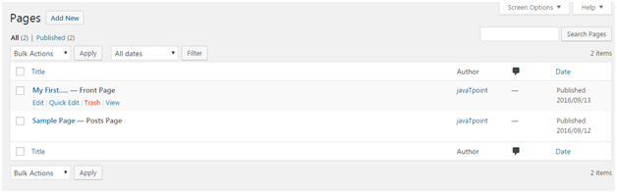
Look at the above snapshot, this is the list of all the created posts. Bring your mouse above a post, following options will appear.
There are two options to edit. One is Edit and other one is Quick Edit.
On clicking Edit, following page will appear.
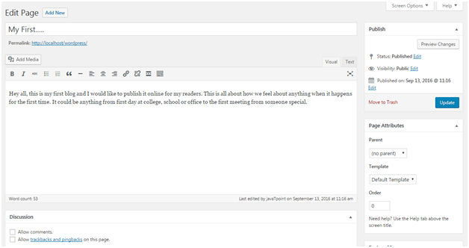
Look at the above snapshot, here you can edit title or content of your post.
On clicking Quick Edit, following page will appear.
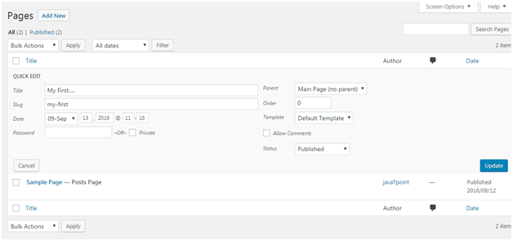
Look at the above snapshot, here you can edit title, date and slug of your post. And if want, you can also change category for your post.

How to Delete a Page
To delete a post, go to Posts > All Pages
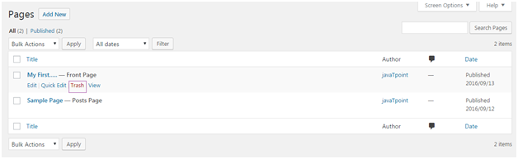

WordPress posts vs pages
- Post and page appears to be same on the dashboard as both are used to add content on your site. People get confused in their usage.
- Pages are static. Then don't change frequently. Some examples of pages are contact us, about us, introduction, etc.
- Posts are what you make an update on your post. They need to change very frequently as they need to keep your site fresh and attractive for your users.

WordPress Posts
Posts allow you to write a blog and post it on your site. They are listed in reverse chronological order in front page of your blog.
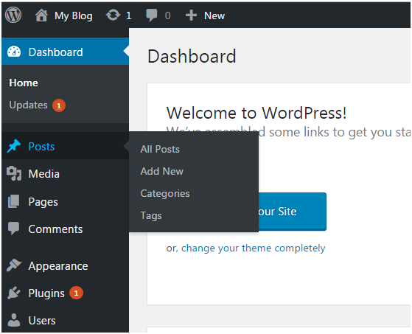
Look at the above snapshot, these are the sub-menus of posts.

How to Adding new Post
Go to Posts > Add New.
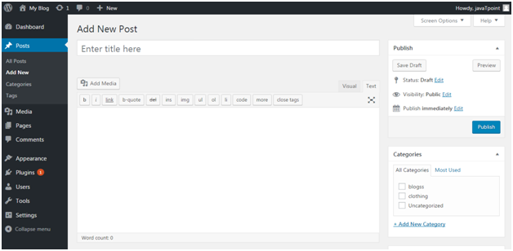
Look at the above snapshot, editor page will appear in front of you. There are two fields,
- Title - Enter the title of your post
- Content - Here you have to write content of your post.
In Visual mode, you can write in normal format.
In Text mode, you can write in HTML format.
Preview - This button allows you to have a look on your post before publishing it.

How to Publishing Post
After filling above two fields click on Publish button. It means you are ready to publish your blog on your site.
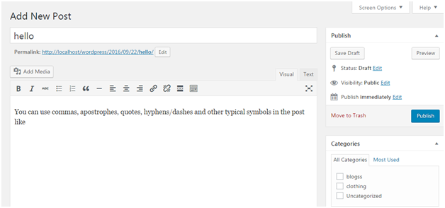
Look at the above snapshot, there are some other options available in publish section.
Preview Post/Preview - Let you see a preview of your post before publishing it
- Permalink - It stands for permanent link. It contains a user-friendly post name derived from post title. This can be edited using "Edit" button.
- Save Draft - A post can be saved here
- Status - Let you change the status of your post to Pending and Draft.
- Visibility - Change visibility to Public, Password protected and Private.
- Publish - Change the post publish date and time

How to Edit Post
To edit post, go to Posts > All Posts.
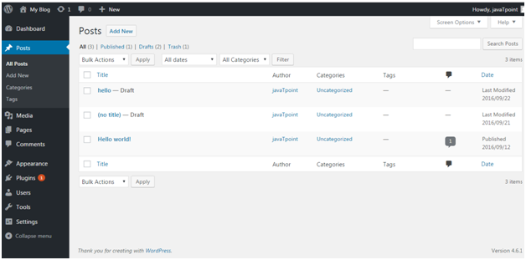
Look at the above snapshot, this is the list of all the created posts. Bring your mouse above a post, following options will appear.
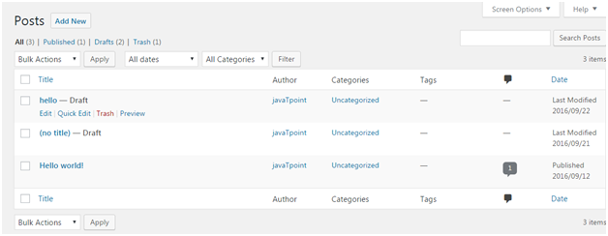
Look at the above snapshot, there are two options to edit. One is Edit and other one is Quick Edit.On clicking Edit, following page will appear.
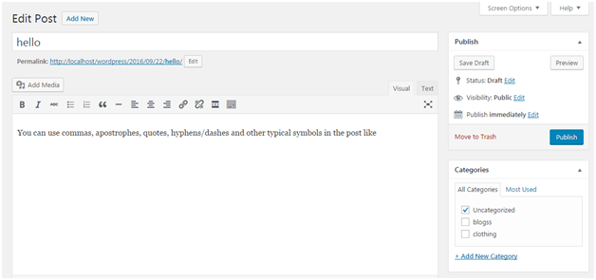
Look at the above snapshot, here you can edit title or content of your post.
On clicking Quick Edit, following page will appear.
    - How to Deleting a Post
To delete a post, go to Posts > All Posts

How to Preview Post
Preview option helps to see you your post before publishing it to the public. It is better to have a look on your post that how it looks before publishing it to the world.
Go to Posts > All Posts
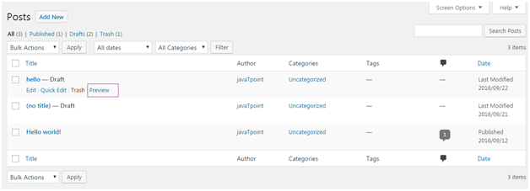
Look at the above snapshot, on clocking Preview, following page will appear.
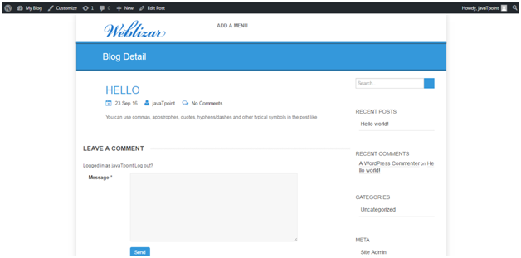

How to Publish Post
From Publish button you can make your post available to your viewers.
Go to Posts > Add New
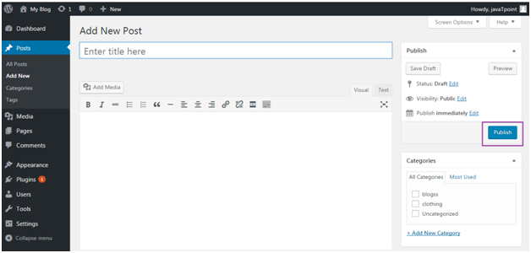
Look at the above snapshot, after writing your post click on Publish button. And your post will be published publically.

WordPress Media Library
WordPress Media Library contains images, videos, audios, and files that can be included in the content when writing a WordPress page or post. We can see many things related to the media in the Media Library, like add, delete, and edit. The following are the steps to understand the WordPress Media Library.
    - Firstly, go to the WordPress dashboard and select the "Media" option and then click on the "Library" option.
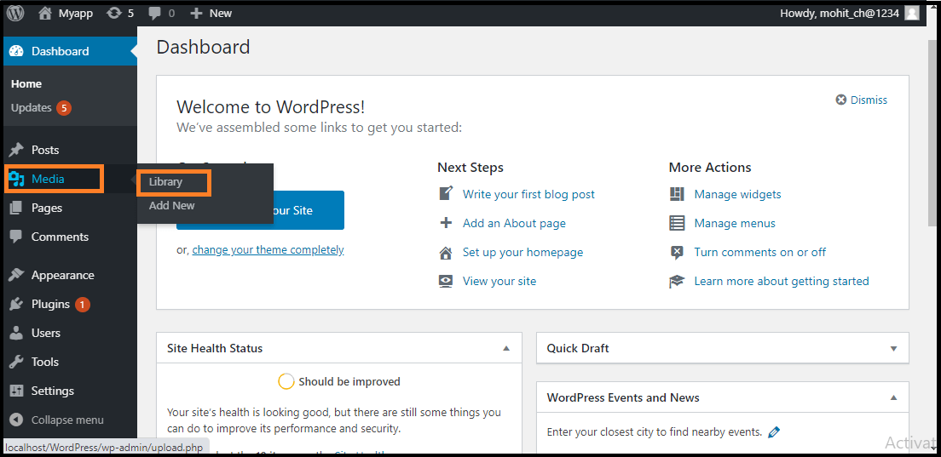
    - When we click on the Library option, we can see the various media files, such as images, videos, and audios. If we want to add new items, click on the "Add New" button.
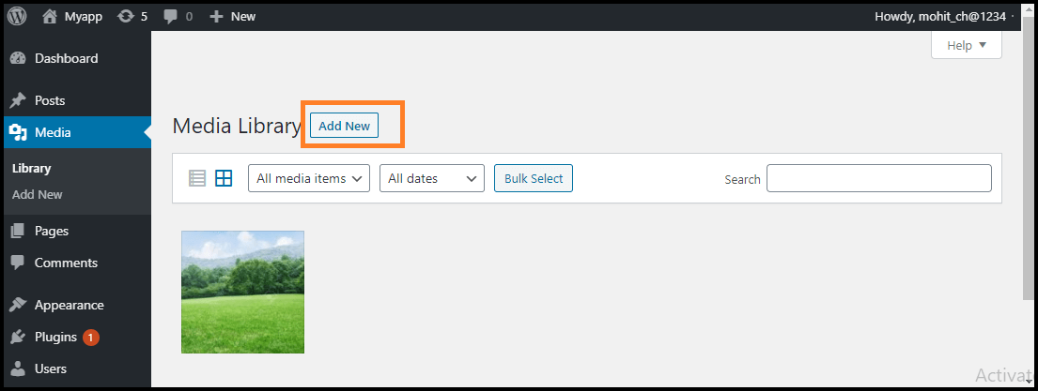
    - We can see a menu bar in the Media Library that consists of many things like List view, Grid view, Filter the images and videos, and search box, as shown in the following screenshot
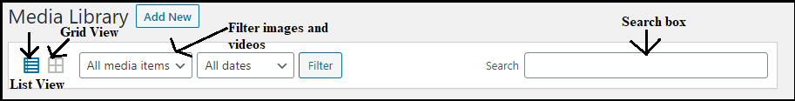
There are various tabs in the Media Library bar, which are as follows:
- List View: It shows the media files in the list form.
- Grid View: It helps to show all the media files in the grid format.
- Filter the images and videos: It filters the images and videos in the media library.
- Search box: It helps to find a media file by inserting the file name into the search box.

Adding the Media Files
WordPress permits us to add various media files, such as images, videos, and audios.The following are the steps to add Media Files in WordPress.
- Firstly, go to the WordPress dashboard and select the "Media" option, and then click on the "Add New" option.
- After clicking on the "Add New" option, click on the "Select Files" option to select the files from our local storage, as shown in the following screenshot.
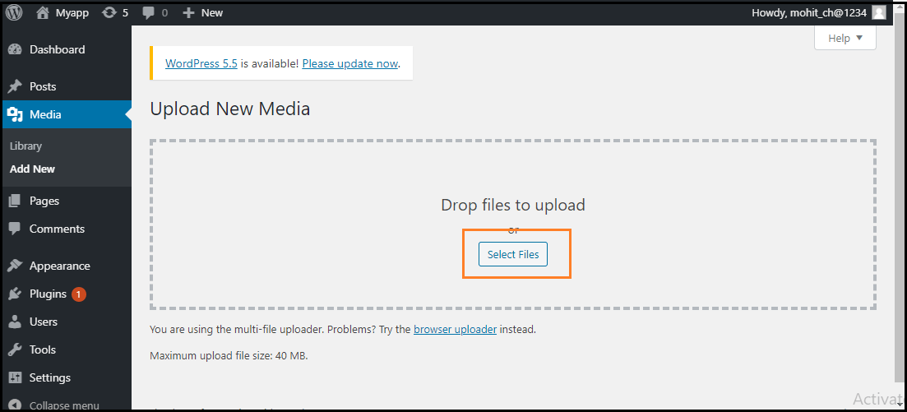
- After clicking on the Select Files, add the media files by selecting them and then click on the open button, as shown in the following screenshot.
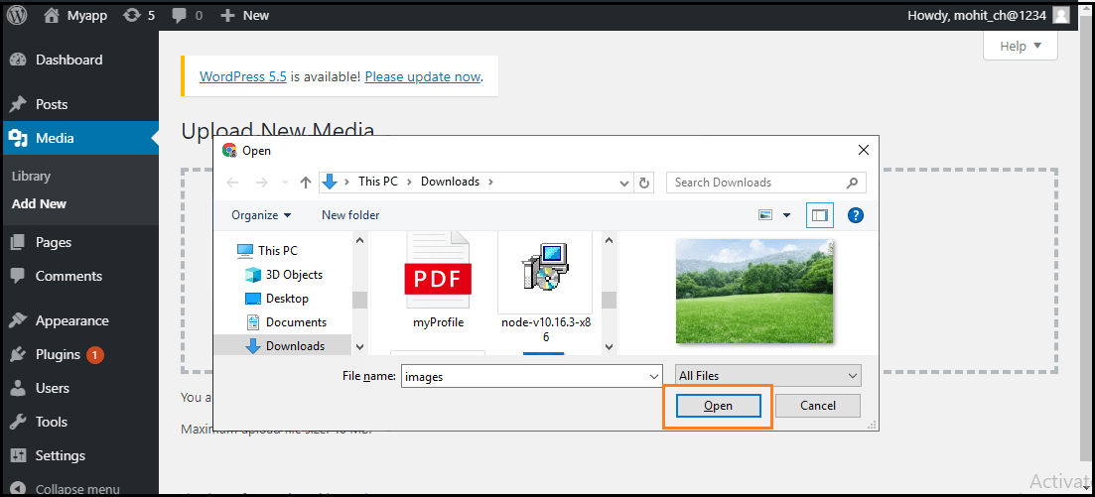
- Now, we will see the media files list that we added in the list.
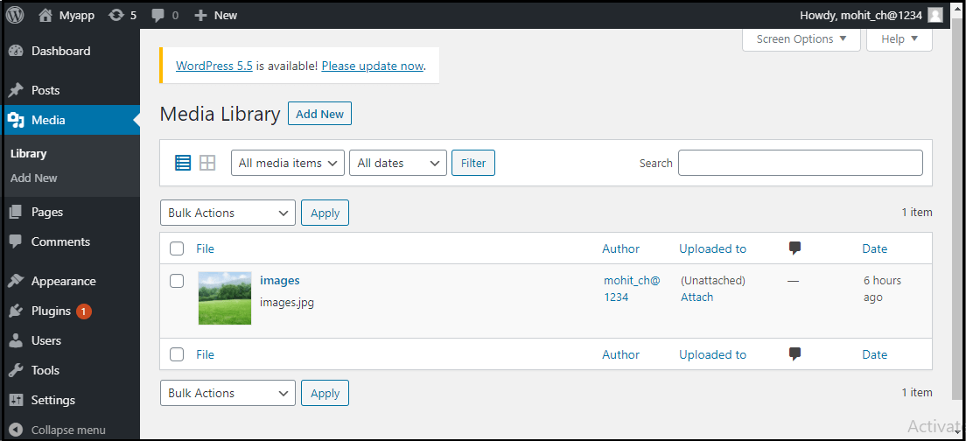

Insert the Media Files
We are going to know how we can insert the media files into a WordPress Page or Post. Media Files can be inserted from the Media Libraries, URLs, or local storage in the WordPress Page or WordPress Post. The following are the steps to insert the Media Files:
- Firstly, go to the WordPress dashboard and click on the "Posts" and then click on the "Add New" option to insert the media file in WordPress.
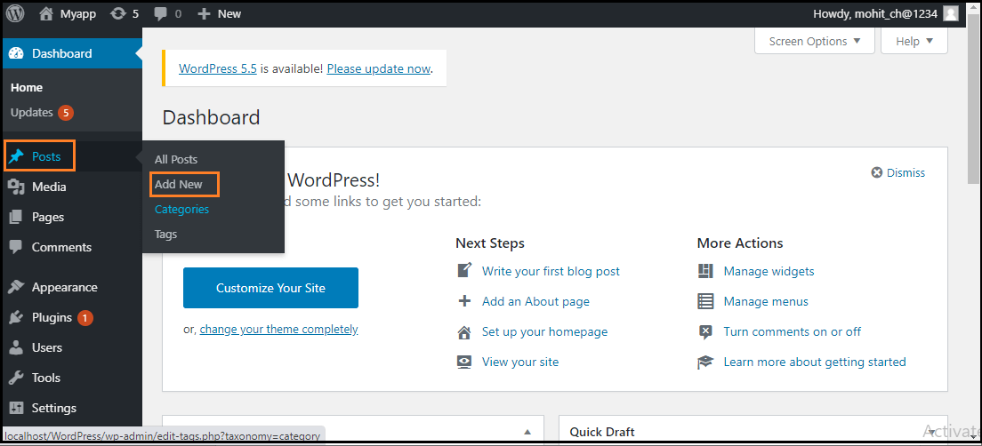
- After clicking on the "Add New" option, click on the "Add Media" button.
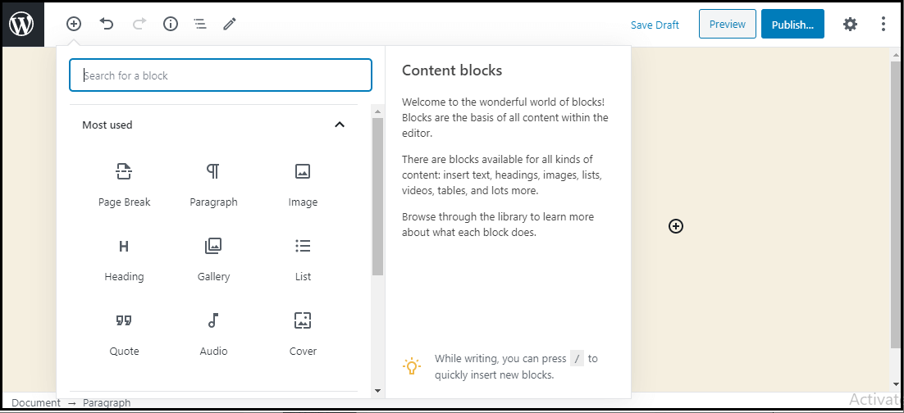
- Now, we can choose the media file from the library section.
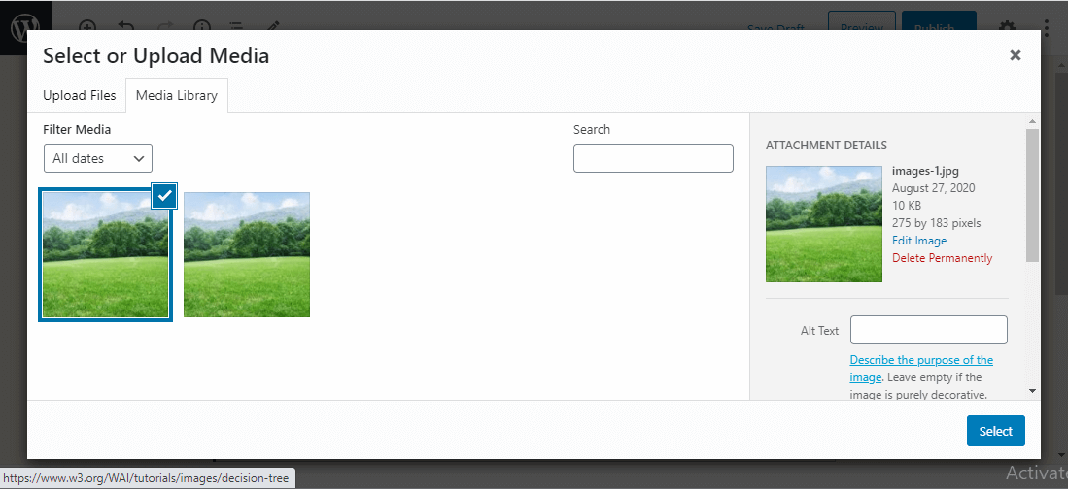
All information on the selected media file will be shown in the Attachment Details on the right side of the screen.
- Now, click on the "Select" button, then the image will be inserted in the page or post of the site.
We can also upload a file directly from the device by clicking the Upload Files button. Just click on the "Select" button.

Edit Media Files
We can handle information about the Media File, which is stored in the Media Library. The following are the steps to edit the Media Files in WordPress.
- Firstly, go to the WordPress dashboard and select the "Media" option, and then click on the "Library" option. After that, click on the media file name or the edit link.
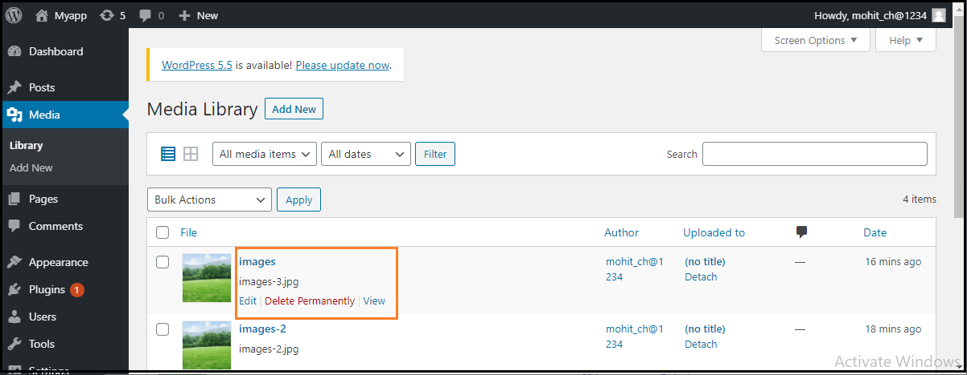
- Here, we will see the Media Files list. Now, we can select an image that we want to edit.
- Finally, we can see the media page with some options shown on the site. The options are as follows:
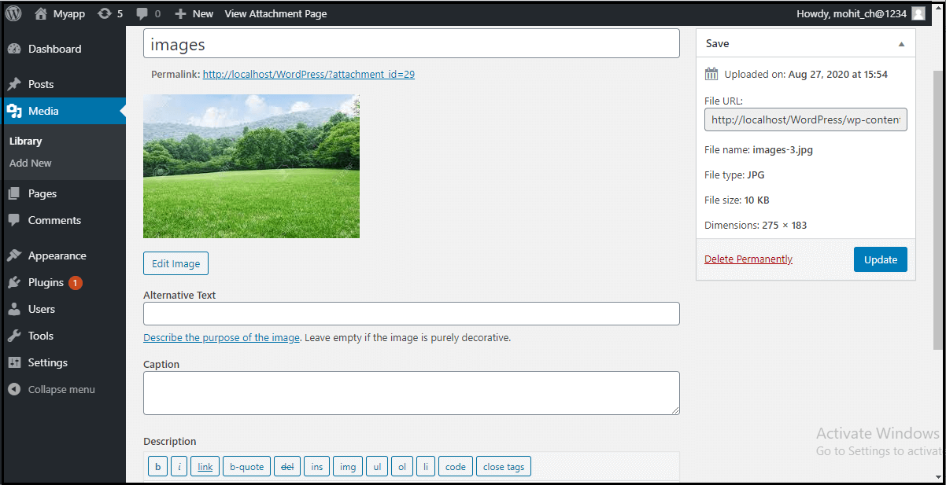
- URL: It helps us to read only a link from the media file.
- Title: It shows the media name. If the themes and plugins are designed to be displayed, the title will often show up in the galleries and attachment pages.
- Permalink: It is the media attachment page URL. It is also a link to see the attachment page of the media file.
- Edit Image button: It helps to edit the position of the image like rotate anti-clockwise, rotate clockwise, flip vertically, horizontally, crop, flip, and more.
- Caption: It allows us to provide a detailed explanation of the media file.
- Alternate Text: The alternate text for the image is used to describe media and is also used for the availability of images.
- Description: It allows us to explain the media file.
- Delete Permanently: It helps us to delete the file permanently.
- After completing all these steps, click on the Update button to save the changes.
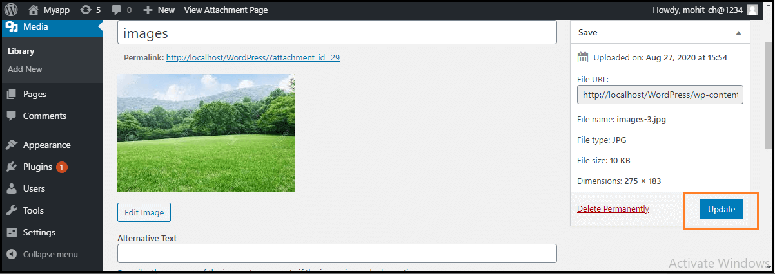
Working with Menus
The Menu is a list of options presented to the user. They are mostly used as a navigation building method on WordPress websites. Usually, the common content management system's installation is followed by a default menu that provides links to pages at the top level. These menus can be used at the top of the sites with links. It is generally used as a horizontal menu with links like home, email, contact, or pages.

Defining a WordPress Menu
Firstly, we need to define a WordPress menu before adding items to it or use it. We can use the following steps to define a WordPress menu.
    - First, log in to the WordPress Dashboard and click on the "Appearance" menu option, as shown in the below screenshot.
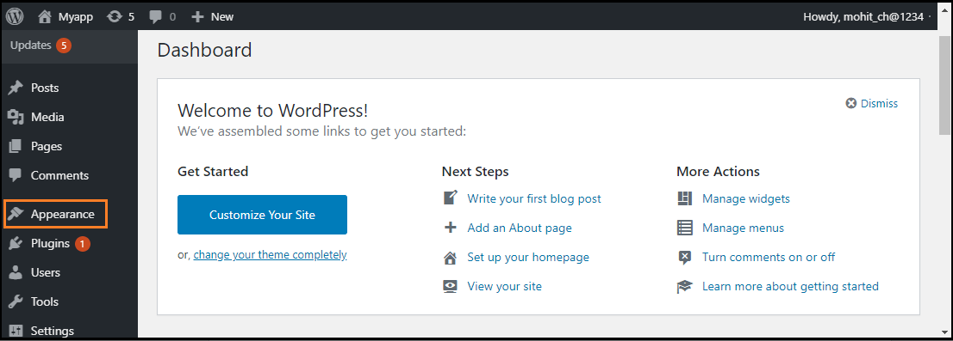
    - The "Appearance" menu option opens a sub-menu where we choose the "Menus" option to bring up the Menu Editor
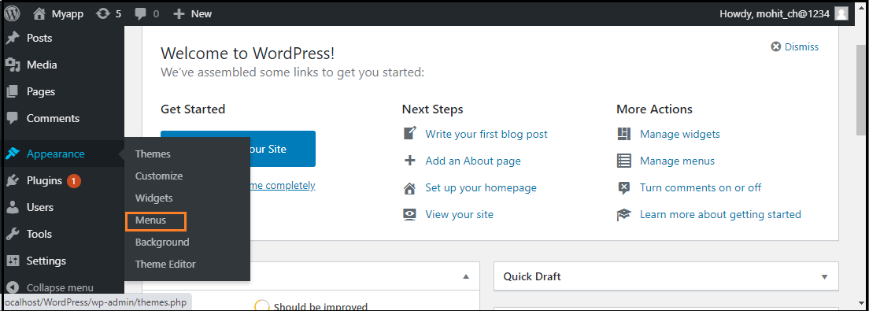
    - After selecting the "Menus" option, choose the "Create a new menu" option shown in the red rectangular box at the top of the page.
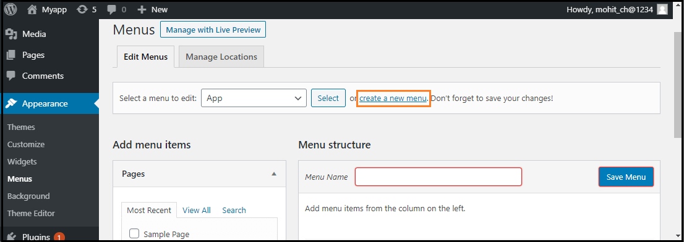
    - Now, enter the name to create a new menu in the "Menu Name" box.
    - After that, click on the "Create Menu" button to create a menu.
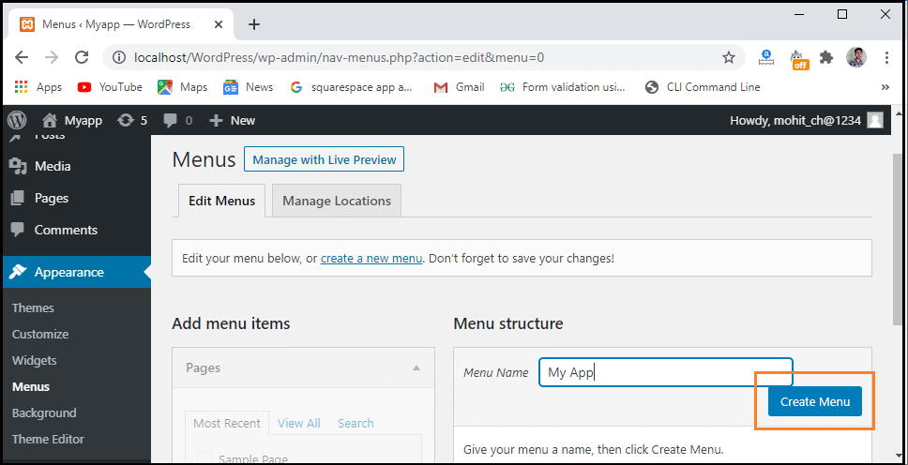

Adding Menu Items
We can add several link type options to the menu like Pages, Posts, Custom Links, and Categories. The following are the steps to add items in the menu.
- Firstly, Find the pane entitled Pages.
- Choose the "View All" link to see a list of all recently published pages on the WordPress site.
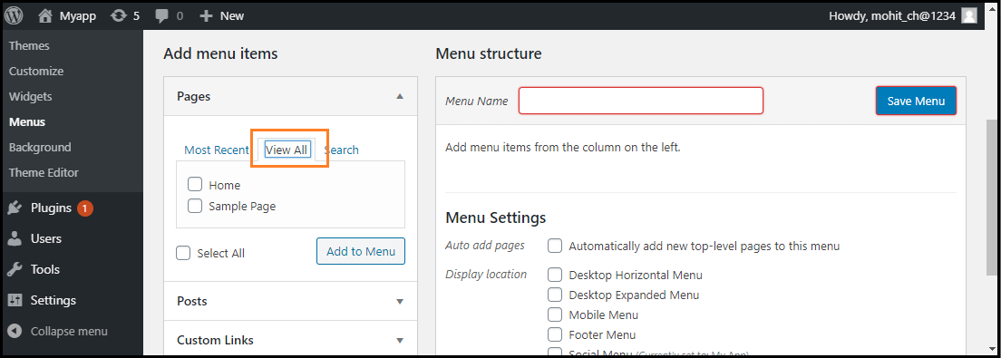
- Now, we can add Pages by clicking the checkbox corresponding to each page title.
- To add our selection to the menu that we created in the previous step, click on the "Add to Menu" button shown in the red rectangular box at the bottom of this page.
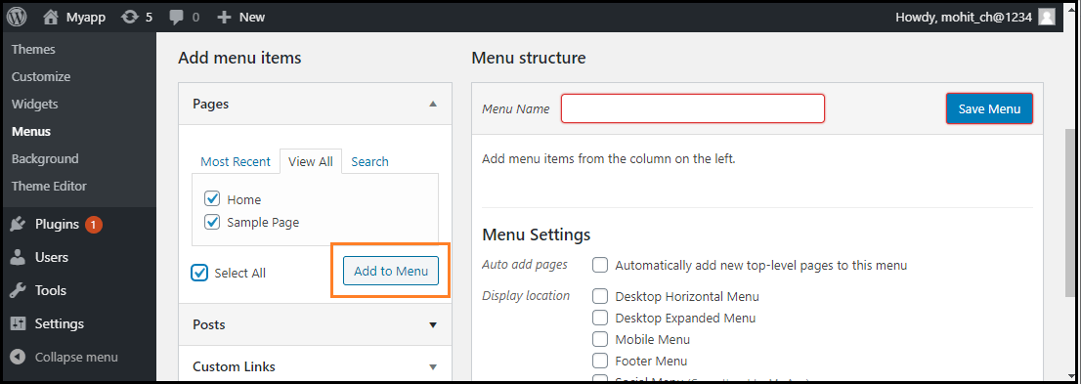
- After that, click on the "Save Menu" button.
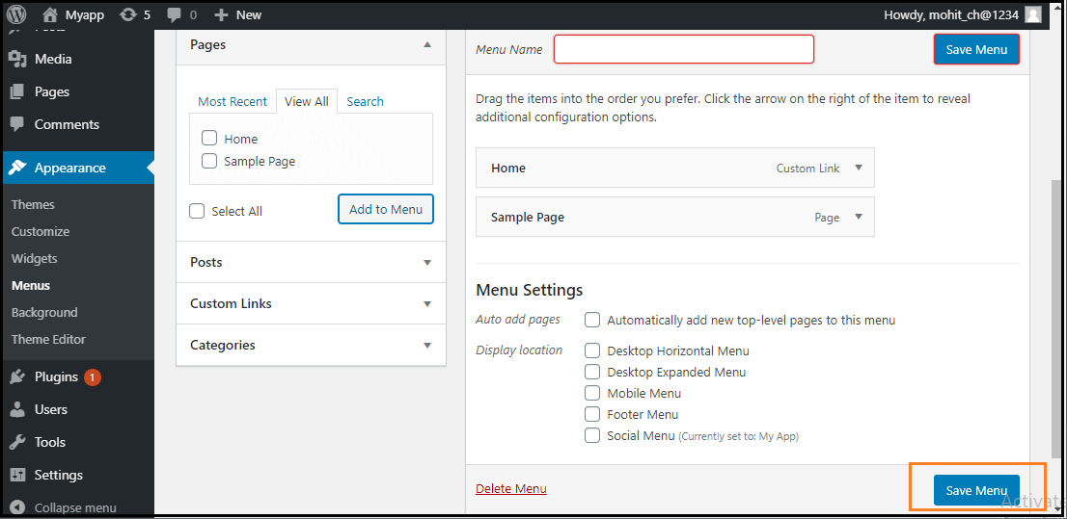

Deleting a Menu Item
If we want to delete an item form the menu, we can use the following steps:
  - First, find the menu items that we want to delete in the menu editor window.
  - Next, click the arrow icon at the top right corner of the menu item.
  - Click on the "Remove" option. The menu item or box will be removed immediately.
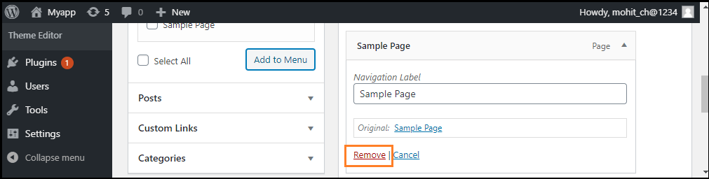
  - Finally, click on the "Save Menu" button to save the changes.

Customizing Menu Items
There are various customization Menu items available; some of them are as follows:
- Navigation Label
- Title Attribute
- Link Target
- Link Relationship
- CSS Classes
- Original

Navigation Label

This field defines the title of the item on our custom menu. Our visitors will see this when they visit our site or blog.

Title Attribute

This field defines the alternative text ('Alt') for the menu item. This text will be shown when the user's mouse is hovering over the menu item.

Link Target

It allows users to choose the "Same window or tab" or "New window or tab" from the dropdown menu.

Link Relationship

It allows us to automatically create XFN features to demonstrate how we are connected with the authors or owners of the site to whom we are linking.

CSS Classes

It provides the optional CSS classes to the menu item.

Original
It provides a link to the source of the menu item that helps us to see the page or post.

Creating Multi-Level Menus
WordPress Menu Editor helps us to build a multi-level menu using the "drag and drop" interface. We can drag the menu items up or down to change the order you want to appear in the WordPress menu. We can also drag menu items left or right to build sub-levels in the Menu.
If we want to create a menu item a subordinate of another, it is required to place the "child" under its "parent" and then drag it slightly to the right. If we want to create a multi-level menu, we can use the following steps:
Step 1: Firstly, move the cursor over the "child" menu item.
Step 2: Drag it to the right while holding the left button of the mouse.
Step 3: Now, release the mouse button.
Step 4: Repeat all these items for every sub-menu items.
Step 5: To save the changes, click on the "Save Menu" button in the Menu Editor.
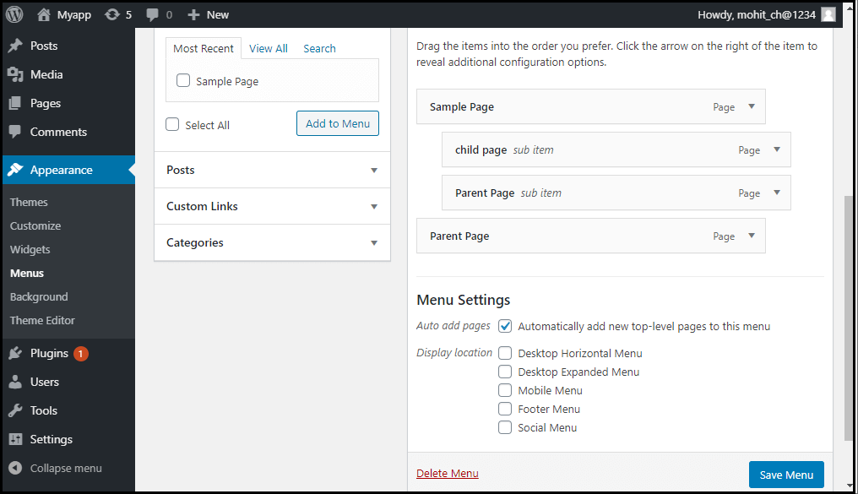

How to add custom links to the Menu
If we want to add the WordPress menu's custom links, we need to follow these steps:
Step 1: First, we need to click on the Custom link option in the menu's left column. Every custom link requires a URL and the Link Text.
Step 2: After that, click on the "Add to Menu" button to add a link.
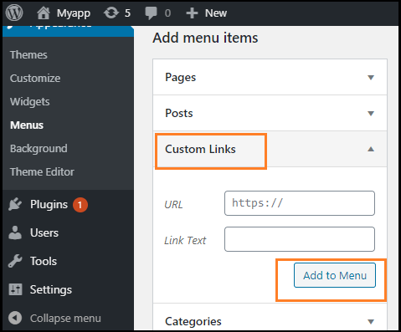
These custom links are useful for situations when we need to link to a page not listed in the left column, such as an external website.

How to link to category pages or tags
If we want to add the post categories or tags to our menu, we can use the following steps:
Step 1: First, click on the categories tab in the left side column.
Step 2: Now, choose the one tab that should appear in the menu.
Step 3: After that, click on the "Add to Menu" button to add a category or tab.
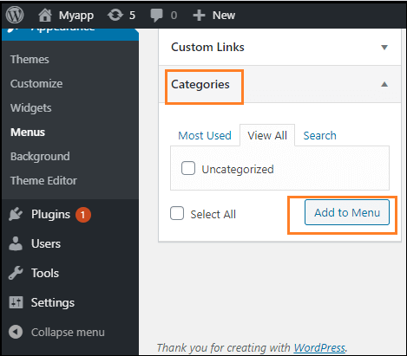

How to Add a social menu
Creating a menu for our social accounts is much easier than creating a regular one. To create a social account in the WordPress Menu Editor, we can use the following steps:
Step 1: First, click on the "Create a new menu" link.
Step 2: Now, input the name of the menu and click on the Create Menu.
Step 3: Next, check the bottom of the "Social Links" menu box, and use the Custom Links tab to add links to the social media menu.
Step 4: After completing all these steps, click on the "Add to Menu" button to add a social menu.
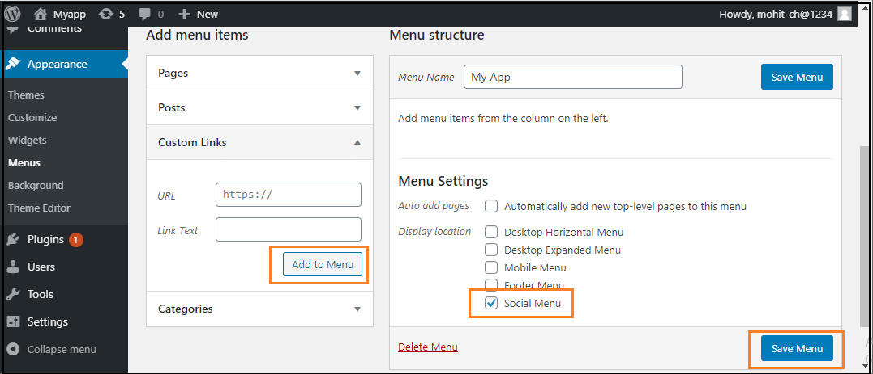
Working with Widgets
Widgets are the pre-built modular element that helps to add specific features to blogs/websites. It can be added in the footer, sidebar, etc..
The area where widgets will be added also depends upon the theme that you are using. Most of the themes allow using widgets in the footer and sidebar whereas some themes also allow using widgets in the header and homepage.
Some Popular Widgets of WordPress:
- Meta Widget: It helps you or anybody to log in directly into the WordPress control panel from the main website.
- Email Subscriber List Widget: Many email marketing software can be integrated with WordPress by adding some simple lines of code. So by this, we can get the functionality of email subscription
- Search Widget: This will add a search bar to your page. So that the user can type any heading of the article that he wants to search and after that, your website will find that and show it to the user.
- Author Widget: This will add the “About Author” section on your website. So that users can know about the author of that blog and can connect with the content.
- Calculator Widget: This will add a calculator to a page. Users can do whatever calculation he/she want to do on that calculator.
- Call Button Widget: This widget helps you to add a call button on your WordPress site so that users can directly click that button and call you.
One example of these types of widgets is WP Call Button. You can add that in a sticky position so that whether users scroll up or down this button remains stuck to one corner of the phone/Desktop.
- Contact Form Widgets: This will add a contact form on our website. So that whenever a user has any query then he or she can submit their name, email address, and query. After that, the author will solve their query and can send him a solution in the submitted email.
- Social Media count widget: These widgets will show how many counts you have on different social media. This means it will show how many subscribers you have on Youtube, how many followers you have on Instagram, Twitter Facebook, LinkedIn, etc.
How to use different types of widgets in WordPress?
There are 4 types of widgets.
Using Inbuilt Widgets
  - Go to appearance and then in the widget section.
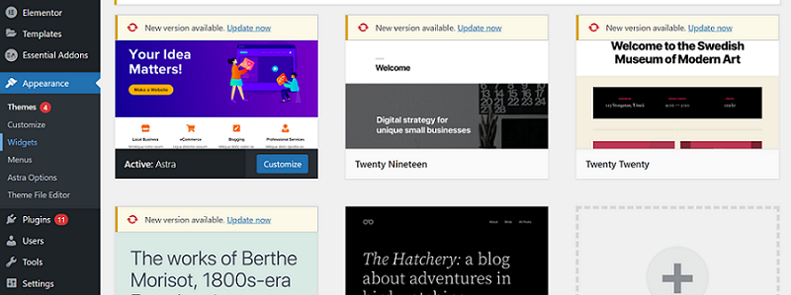
  - After clicking on the widget you can see all the “widgets” on the left side and “area where you need to add widget” on the right side. So you can drag your widget from the left side and drop it to the area on the right side to add that widget in that area.
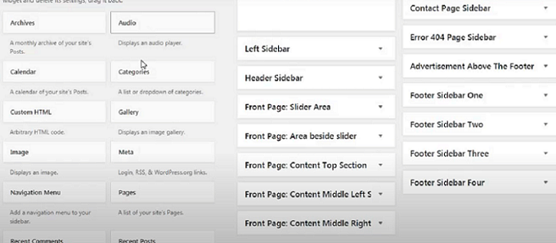
Using a widget integrated with a theme:
- Here also you need to go to appearance and then click on widgets.
- Now you will see inbuilt widgets. So you have to scroll down and then you will see widgets provided by the theme
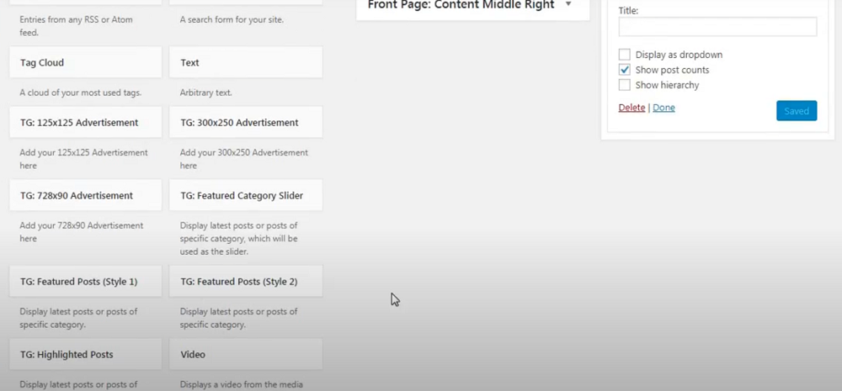
- After clicking on any one widget, you will get all the sections where you can add that widget. So choose any one of your favorite sections for that widget.
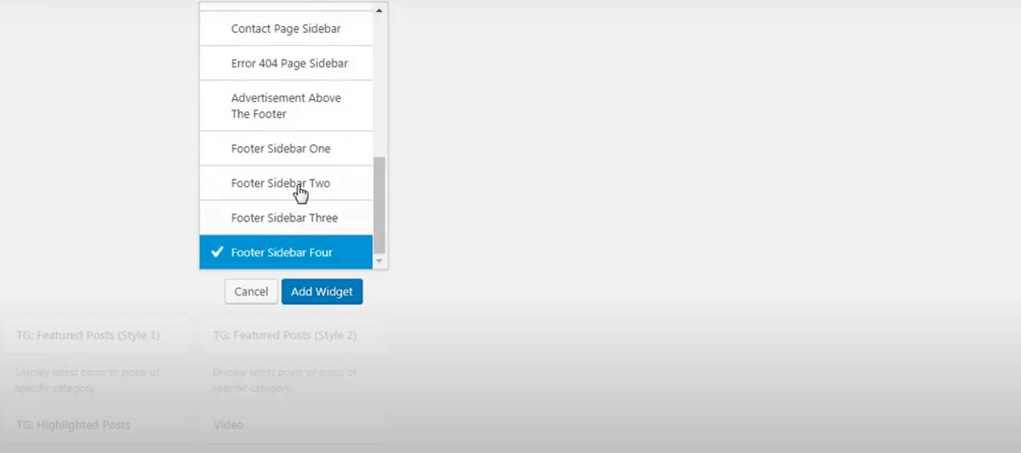
Install a widget as a plugin:
    - Go to the plugin section and click on “Add New”
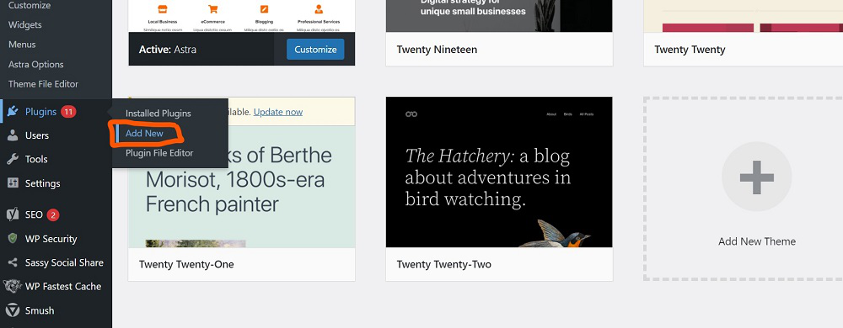
    - Type on the search box on the right-top corner and find your required widget and then install that.
Like here we searched for an Author widget because we want to add an “About Author” section on our website. So we got different options and we will install anyone from them to get the required functionality.
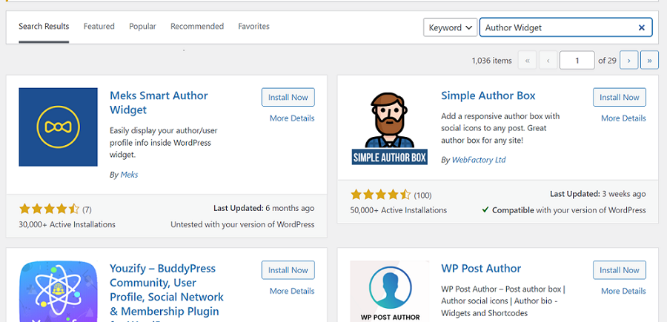
Own widget using Coding:
- Go to appearance and then go to theme section and in that click on theme file editor
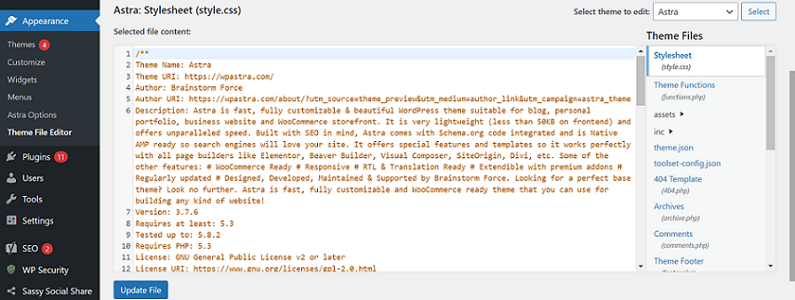
- On the right side you will get many themes files and in those choose “function.php” .Then in the last of their code add your coded widget’s code. After that click on the update file
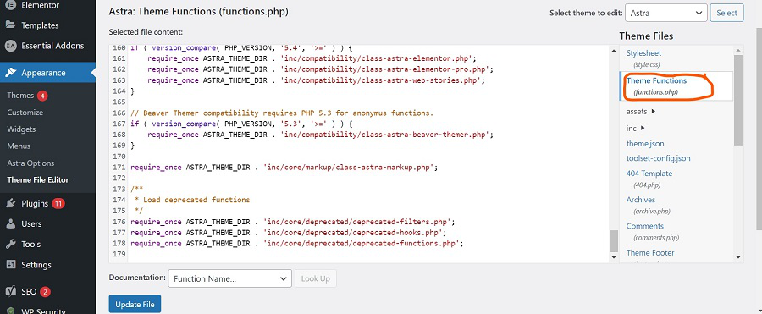
Unit – V

WordPress Themes
- With the help of WordPress theme, you can design the layout and appearance of your website in the front-end.
- When WordPress is installed, it has a pre-installed theme which is very simple and unattractive. But no one wants a website to be that much simple. To make it more attractive one can install and apply different themes from WordPress.
- Themes provide a style (including font styling), colors, page layouts, widget positions, etc. You can change the theme of your site without changing the content of the site. Themes provide a unique look to your site.

Types of WordPress theme
There are thousands of themes available on the WordPress. Some are free and some are paid. You can choose a theme according to your choice.
Free
WordPress provides many good looking themes absolutely free in the WordPress theme directory. If you are using your site for a small audience or yourself, go for free one. Because there are some chances that same theme is being used by another site.
Premium
Premium themes may cost you starting from $1,000. Prize varies depending upon the design and requirement of your site.
One advantage in premium themes is that they provide a reliable code base and offer support. It gives you a more enhanced security.

WordPress theme
Building a WordPress theme is somewhat technical work. To build a theme you should have a little knowledge about the following development languages.
- HTML
- CSS
- JavaScript
- PHP
- Database
You should know how to use a web server.

Selecting WordPress Theme
WordPress theme should be selected very wisely, so that it perfectly fits on your site. You can select any one either paid or free. It should be complemented to your site.
Themes affect a website in a lot of way. Heavy themes which look great may slow down your website and Google will degrade its ranking. If a theme is not coded properly, it becomes difficult to add any plugin or change that theme.
Theme selection is very important as everything for your website depends upon theme. Given below are some of the points which may help the users to select a theme for their website.
Look for Simplicity
Your website should look good, but for that you shouldn't compromise with your site's functionality. Theme styling should not be complicated. Complexity will make things difficult for your users. All you need is a good theme, so don't go for an attractive one compromising your users.
Responsive
Your theme should be compatible with all type of screen sizes. A large number of traffic generates from devices other than laptops and PCs. Google also gives better ranking to the responsive sites. Lot of themes is by default responsive but still there are some themes which are not responsive. So look for a theme which is responsive to make your website accessible by all device users.
Browser Support
Make sure the theme you select is supported by all the browsers. Before selecting it, test it on different browsers for mobiles as well as laptops like Chrome, Internet Explorer, and Firefox.
Plugin Support
Plugins are very important for a WordPress site. They enhance the functionality of your site. Make sure that your selected theme must support all the popular plugins.
Multilingual Support
Your theme should support multilingual to support different languages for users.
Help Option
Only some developers provide support option with free themes, not all. So, if you messed up with your site then you may have to solve it on your own. So rather than facing all these problems, you should better choose a theme which has a good documentation and support help option.
SEO Friendliness
To increase your site performance on search engines, choose a theme which is SEO friendly. Many theme developers will let you know whether their theme is SEO friendly or not.
Ratings and Reviews
Before downloading a theme, have a look on its rating and reviews. A theme has both good and bad reviews, but if there are more negative reviews then read it carefully and consider it once again.

Install WordPress Themes
For theme installation, first you need to select a theme either free or a premium one. There are a lot of sites from where you can download a theme. Theme will be downloaded in zip format. The next process is installation process. Installation has some steps to be followed.
There are two methods from which you can install a theme:
- Installing WordPress using admin theme search
- Installing WordPress using upload method

Installing WordPress using admin theme search
To install free themes from WordPress.org directory, login into your account and click Appearance > Themes.
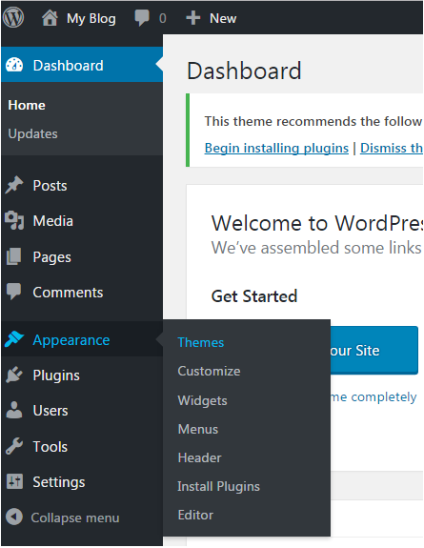
Look at the above snapshot, click on Themes option. Following page will appear in front of you.
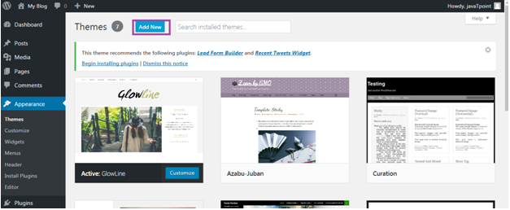
Click on Add New button to Add New themes.
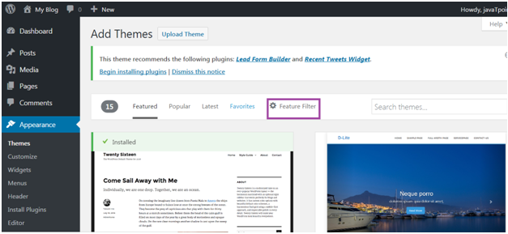
Look at the above snapshot, here you'll see an option for Feature Filter.
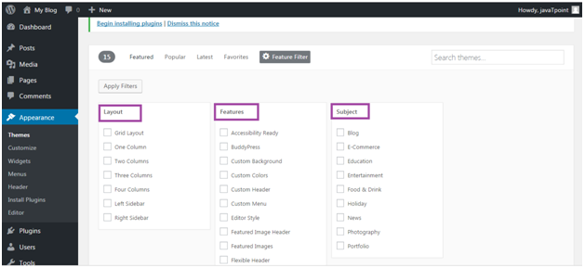
Look at the above snapshot, here you can filter your search for themes by applying your choice for Layout, Features and Subject.
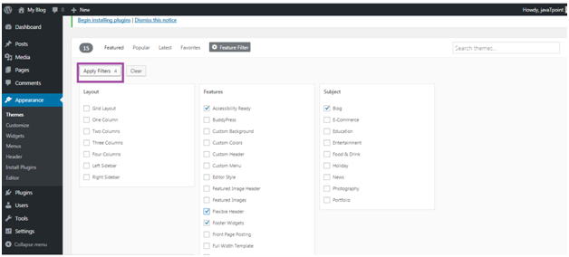
Look at the above snapshot, we have selected 4 filter criteria, now click on button Apply Filters 4 to apply the filters.
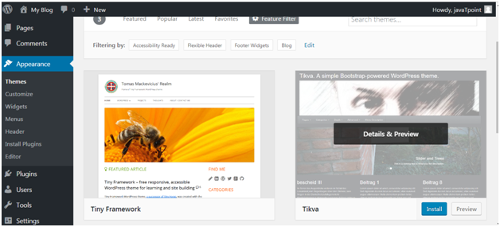
Look at the above snapshot, select a theme and take your mouse above it. Click on Install button.
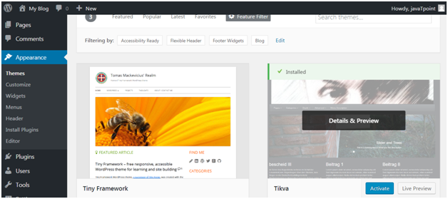
Look at the above snapshot, our theme is installed. To activate it click on Activate button. And you have successfully activated your WordPress theme.

Wordpress Users

User Role
User role determines the access permission to the users of a WordPress site.
There are five user roles:
- Administrator - An administrator has full rights over a site. They can do anything from adding a post to deleting the other user's post. They have the authority to design a website by installing plugin and adding themes. They can even change the existing user?s password, delete them or add them.
Administrators are basically the site owner and they have the full authority over their site.
- Editor - They deal with content section of a site. They have the right to add, delete, edit, or publish even others posts. They can also add, delete, or edit comments.
- Author - They only deal with their own posts in all manners like creating, deleting, editing, publishing or uploading images and videos. They can delete their post, even if that is published. They can't create a new category, they have to choose from the existing one. Although they can add tags to their post.
They can't add any page or modify it.
- Contributor - A contributor doesn't have right to publish their post or page. They have to send their post to the administrator to review. And once it is reviewed, it can't be further edited by the contributor.
They can't even upload image or videos files in their own posts.
- Subscriber - Users which are subscribed to your site can log in and update their profile. They have the authority to change their passwords when they want. They can only read posts and leave comments on your posts.
- Follower - They don't have any right. They can only read and comment on your post. They are only signed up in your site to receive notifications every time when you update a post.
- Viewer - They can only read and comment on a post.
PROTECTING WORD-PRESS WEBSITE FROM HACKERS?
Ans:
- InstallaWordPresssecurityplugin
Security is crucial to running your website smoothly and issue-free. Since we’re talking about Word Press here, you can bet there is a plugin to handle your site security. Infact, there are many of them. These are the top 5 Word Press security plugins to consider:
- IThemes
- Word fence
- Sucurity
- All in OneWPSecurity & Firewall
- Shield Security
- Scan your website for malware
- Invest in secure hosting
- Fortify oursite with strong credentials
- Update your WP, themes and plugins
- Backup
- Enable WordPress firewall
- Hide your WordPress login URL
- Limit login attempts
- Use two-factor authentication
- Password protect your login and adminpages
- Automatically logout in active users
- Manage your WordPress file and server permissions
- Hide your WordPress version
- Manage your WordPress user permissions

